**Chapter 7 A/P**

*In This Chapter:*

**7.1 New Supplier**

**7.2 Manage Supplier**

**7.3 New Invoice**

**7.4 Manage Invoice**

**7.5 New A/P Credit Note**

**7.6 Manage A/P Credit Note**

**7.7 New A/P Debit Note**

**7.8 Manage A/P Debit Note**

**7.1 New Supplier**

This section is for the registration of new supplier as well as for supplier data maintenance.

* To open New Supplier, on the **SmartLeg@l** navigation, click **A/P** and go to **New Supplier**.

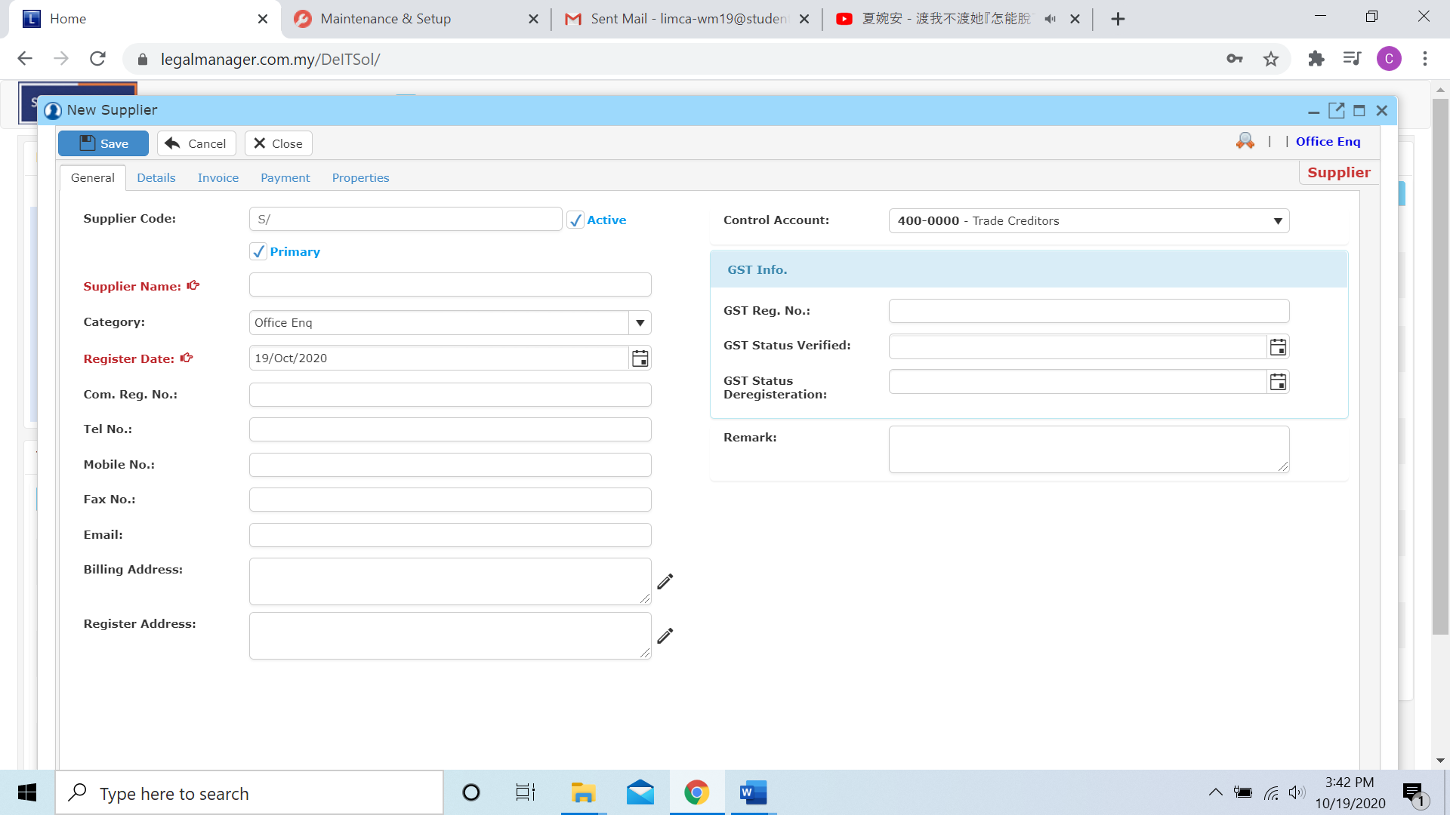

* Fill in all necessary information and it will make the process easier while mail-merge

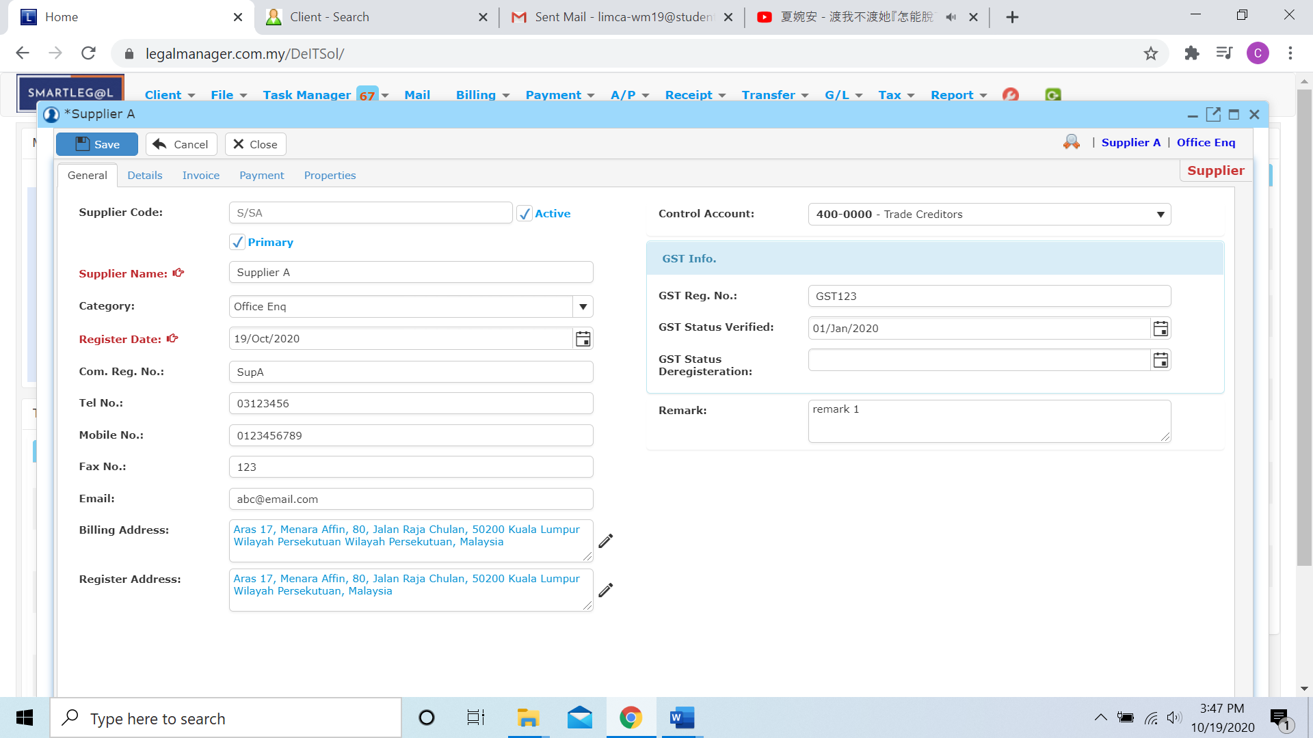

* After you finished to fill the general information, click to the next tab ‘Details’

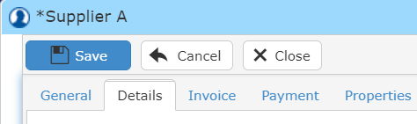

* You are required to have an existing supplier record or create a new supplier before adding supplier details and contact.
* There are 6 remarks fields provided for user to input useful data.

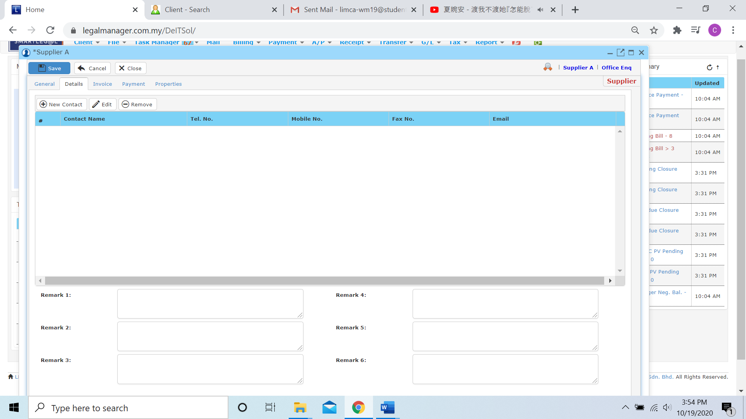

**New Contact**

* You can add new contact of supplier by clicking , after you click ‘New Contact’ it will pop-up a input form for you to key in supplier’s contact details

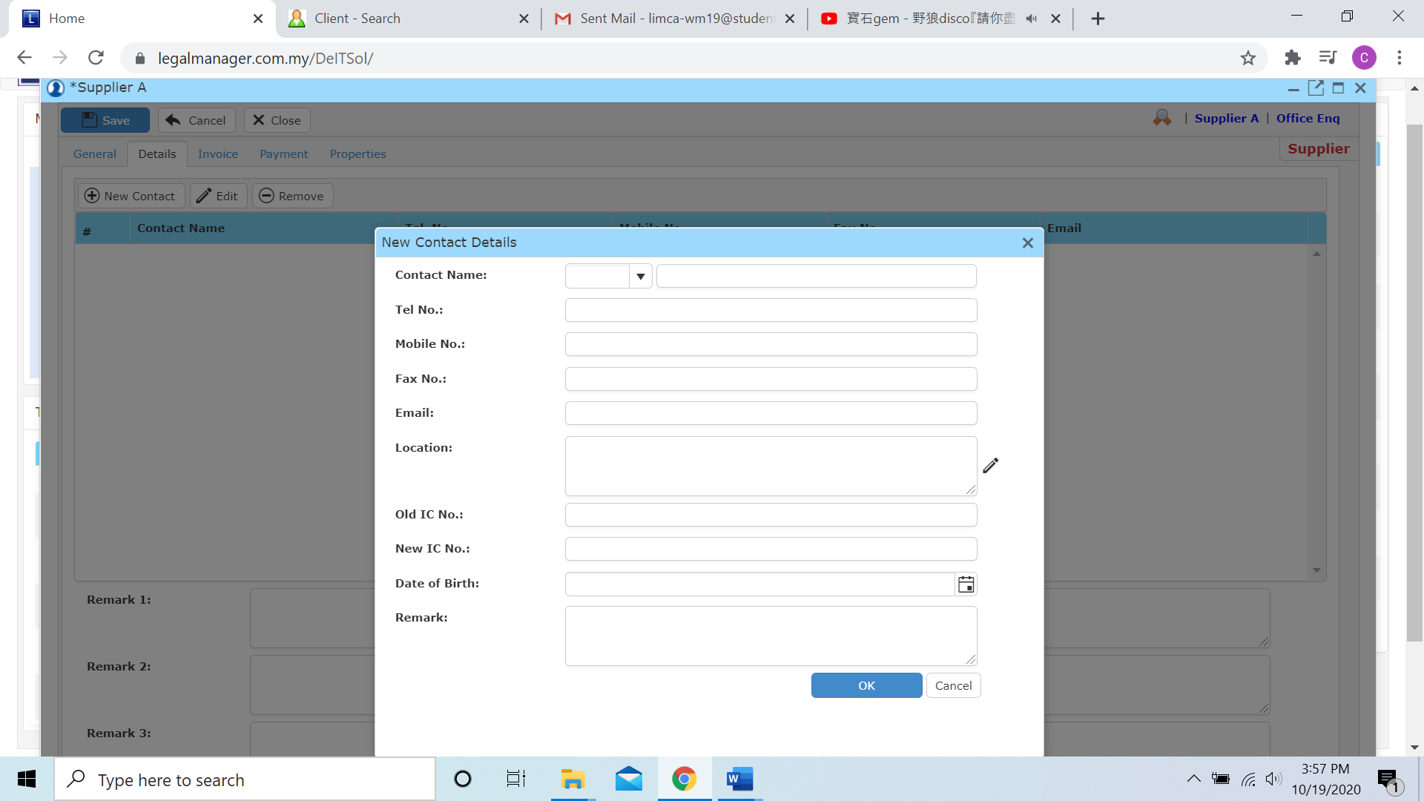

* After you insert all the contact details the record will shown in the table

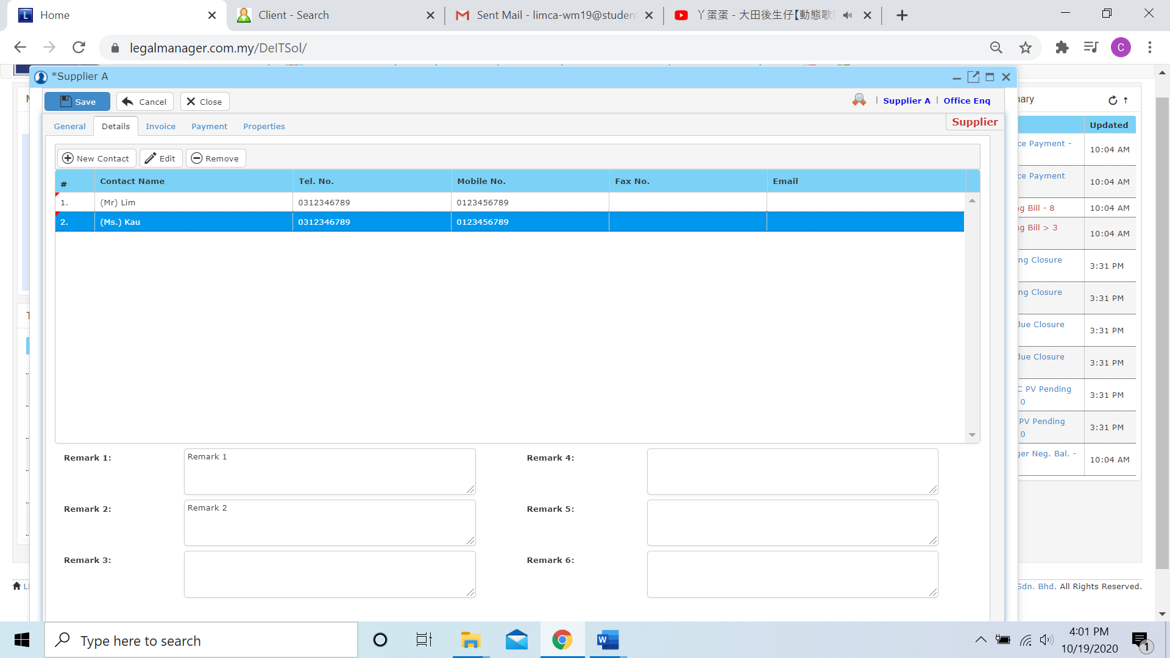

**Edit**

* You can edit the contact you insert into the table; select the record you wish to edit and click ‘Edit’
* It will pop-up the contact details of the record you selected and you can edit those you wish to modify

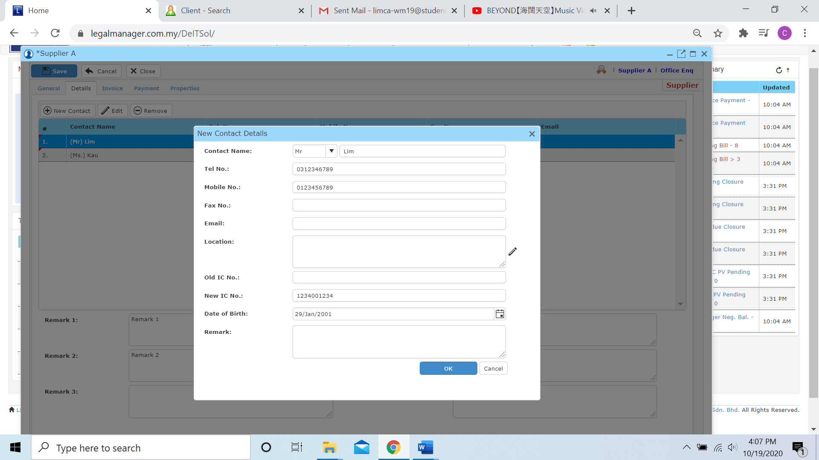

**Remove**

* You can remove the record in the table by selected the record you want to remove

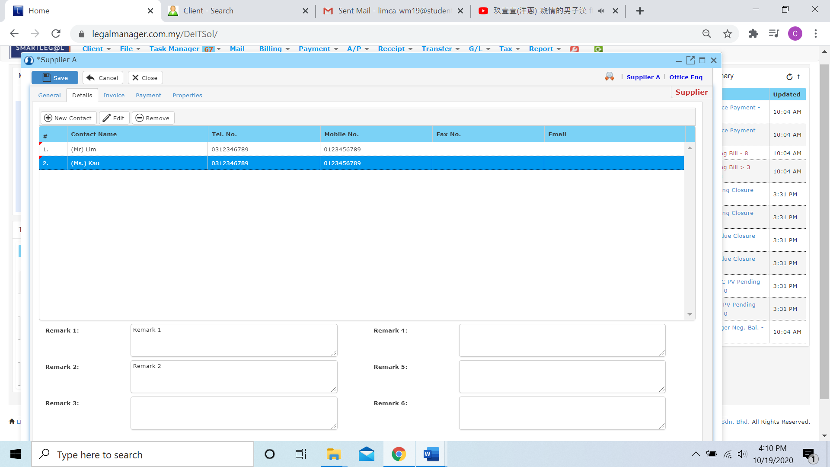

* Click to ‘Remove’ then it will remove the contact you selected

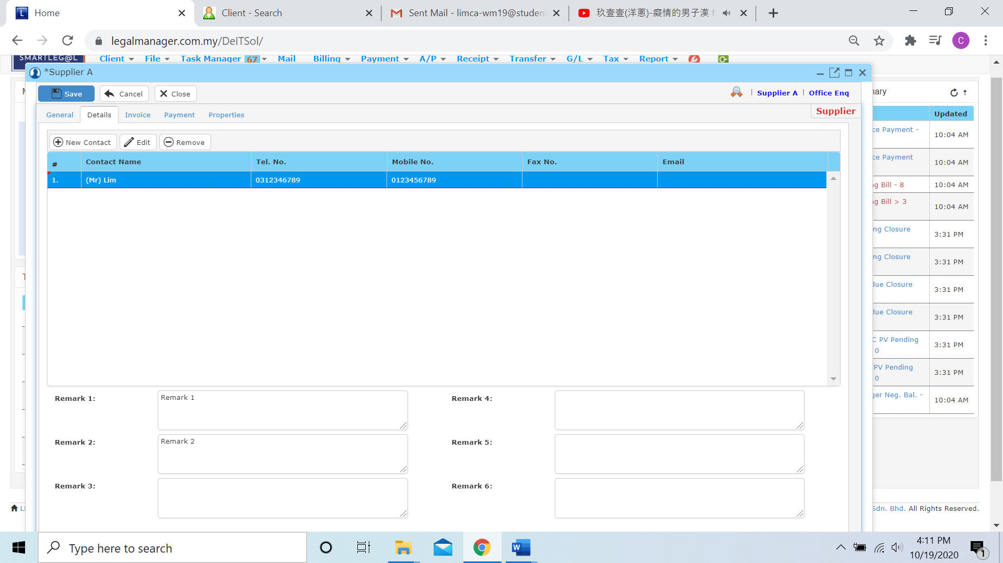

* After that, click to the next tab ‘Invoice’

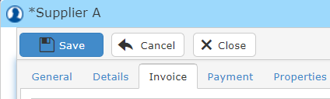

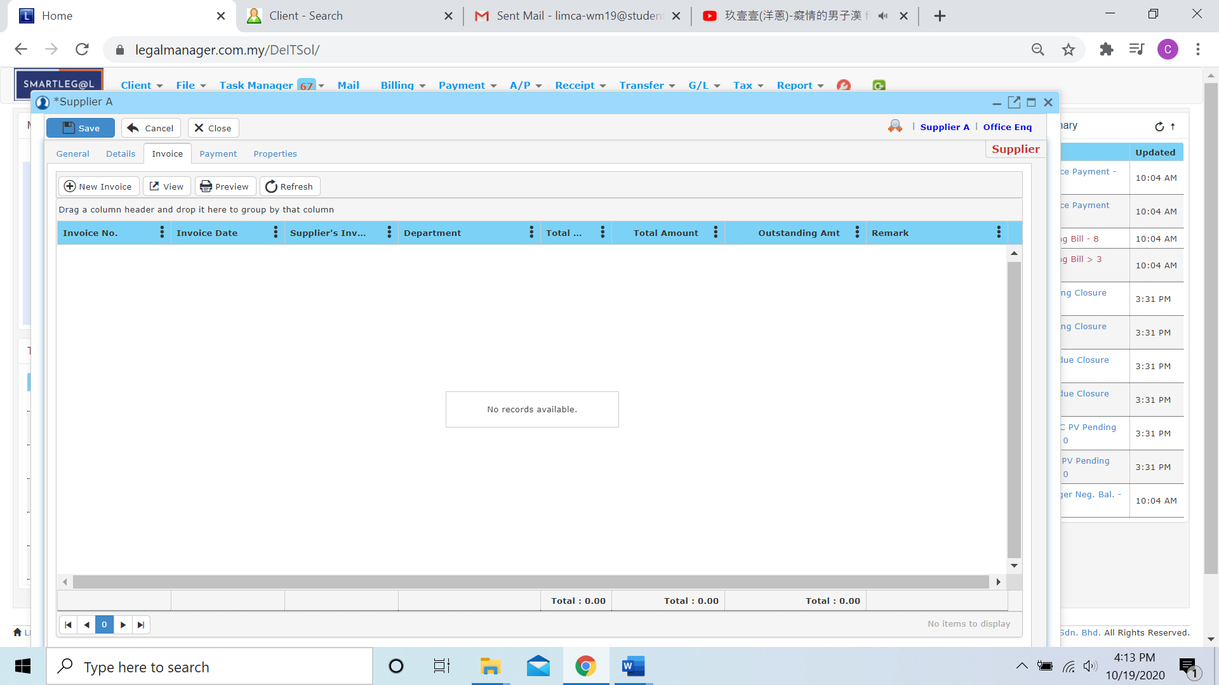

* You can add new invoice for you supplier by clicking  and it will jump to create new invoice function. And please refer to Chapter 7.3 New Invoice

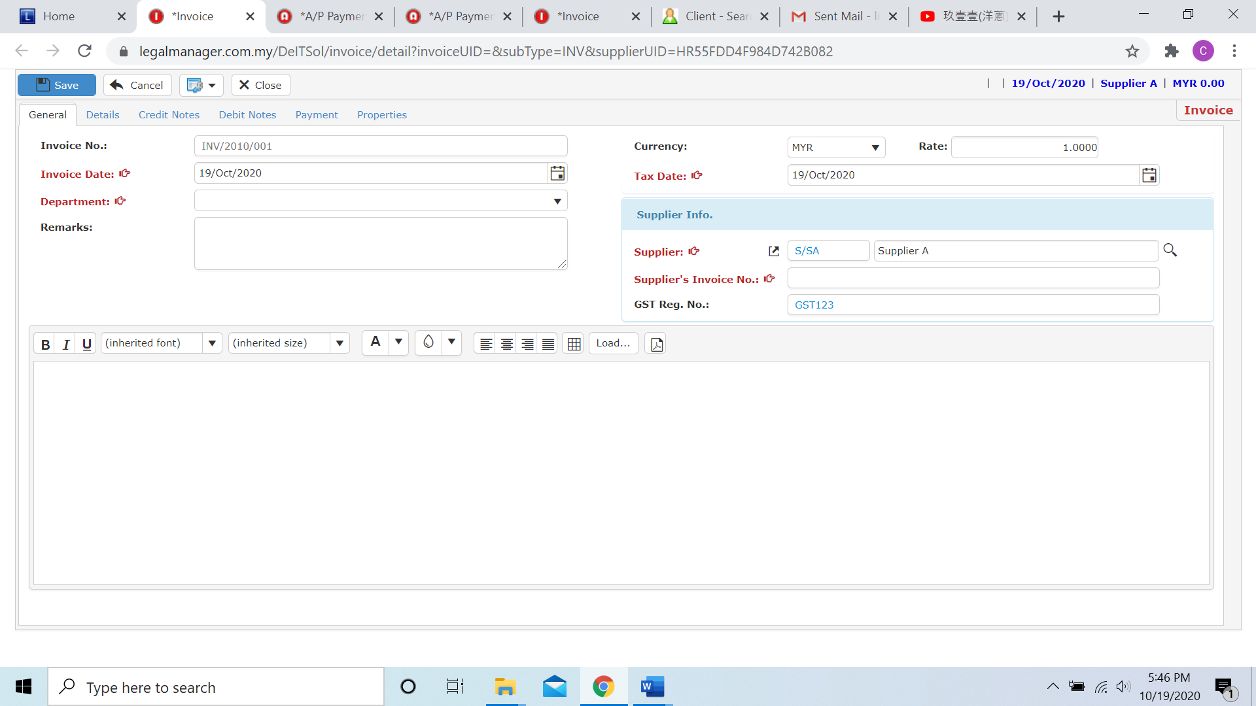

* After you create add invoice for your supplier, you can view, preview or refresh to get make sure the latest invoice
* After invoice, click to the next tab ‘Payment’

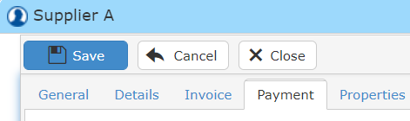

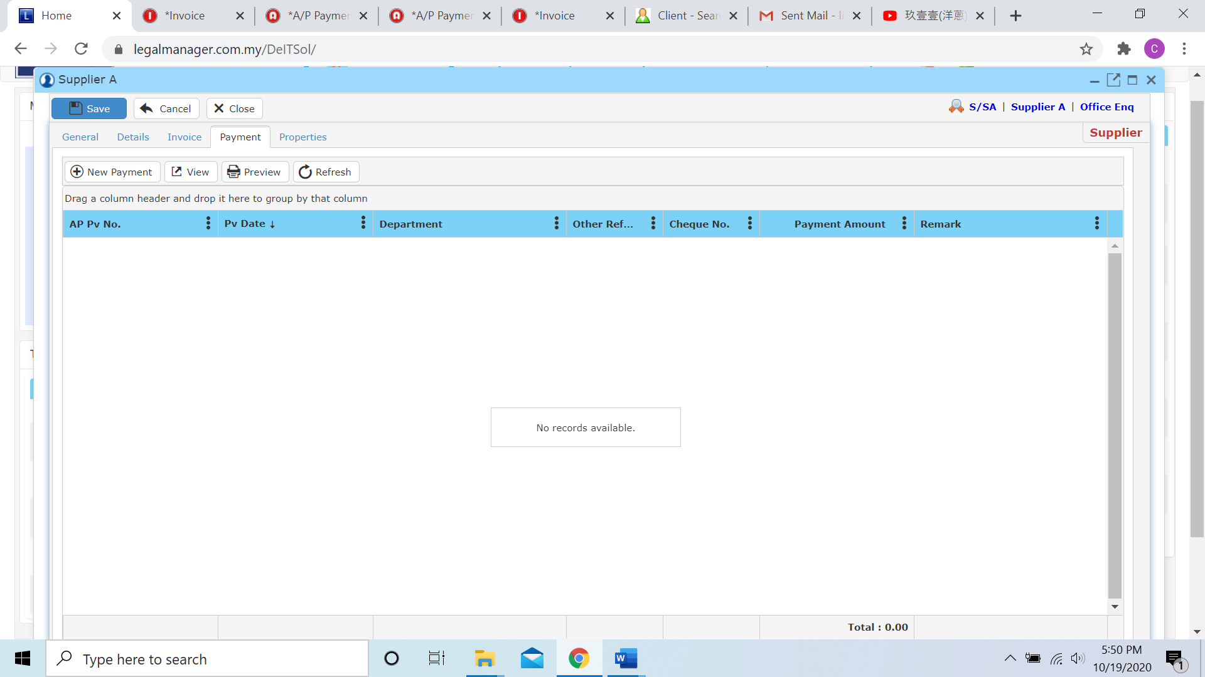

* As well as invoice, you can click  to add new payment for your supplier then while you click that it will jump to the create new payment function. Please refer to Chapter 7.5 New Payment

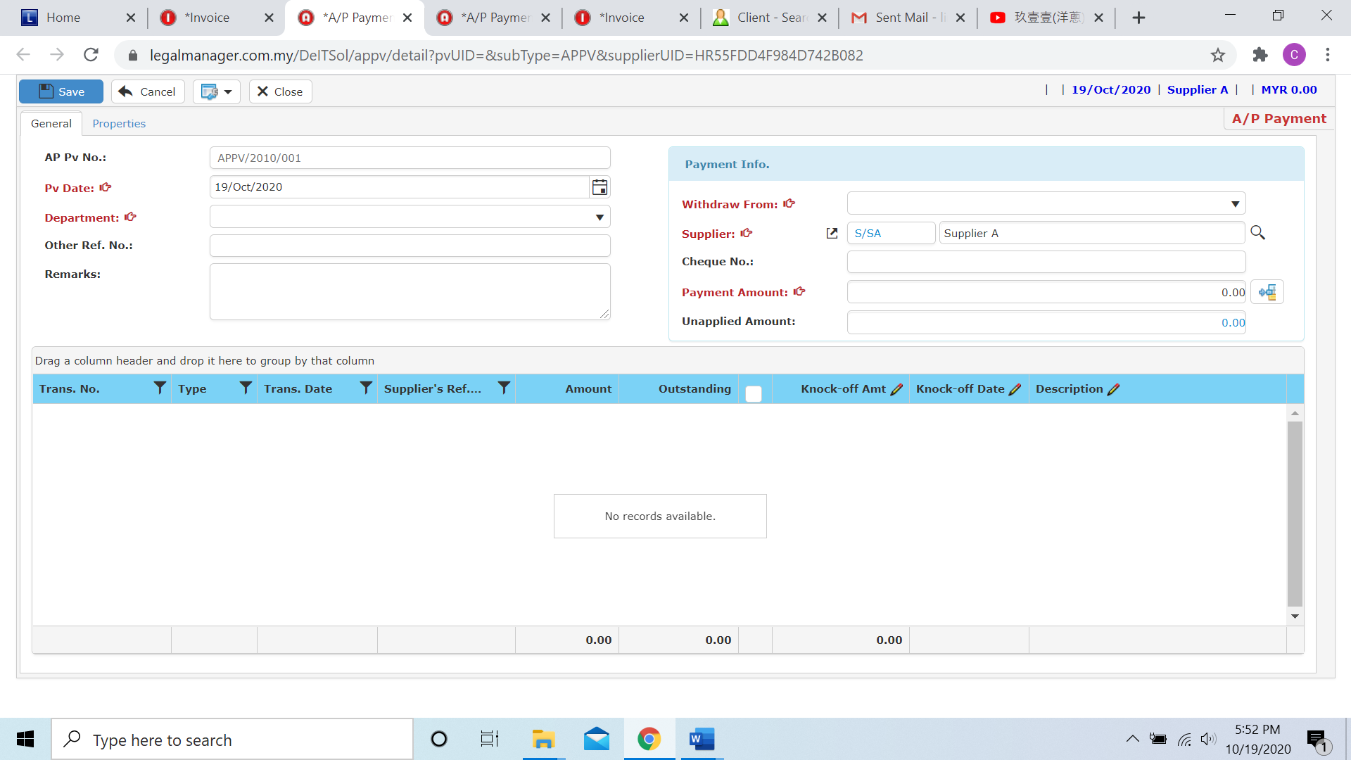

* After you create add payment for your supplier, you can view, preview or refresh to get make sure the latest payment
* The last tab for you when creating new supplier is ‘Properties’

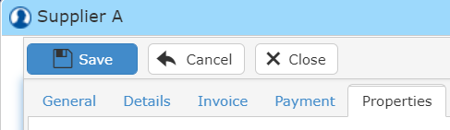

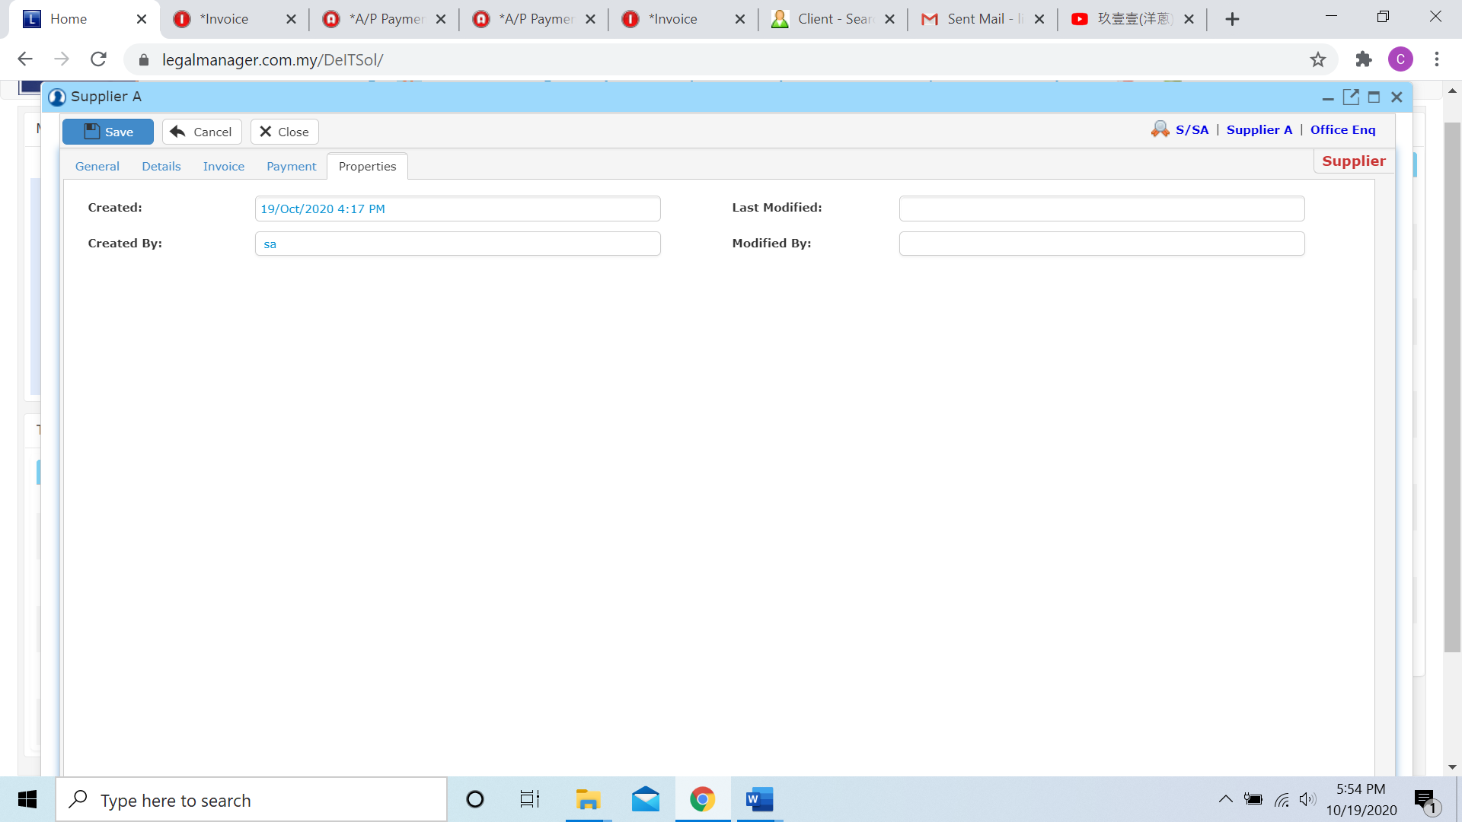

* You can view the information of the supplier once who modify the supplier then there will show the last modified and modified by who
* Once you finish all the instruction above, click ‘Save’ then you are done to create a new supplier.

**7.2 Manage Supplier**

This option enables you to add, edit, and delete a supplier. It also allows you to keep track of supplier details and all related information.

* To open Manage Supplier, on the **SmartLeg@l** navigation, click **A/P** and go to **Manage Supplier**.

**Manage Supplier**

* Search the supplier you wish to manage through type the search criteria or search by advanced.
* To start a new search or to clear the search results, click ‘**Clear**’.

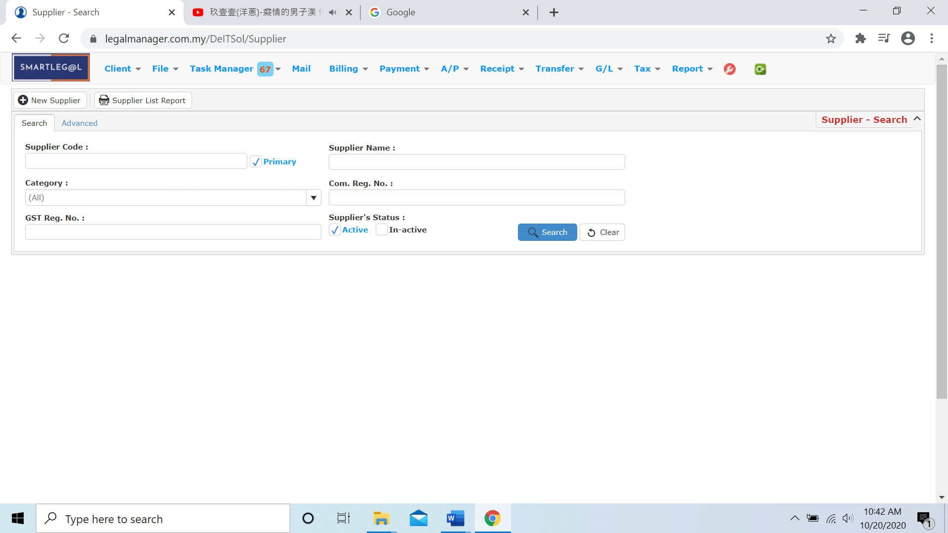

Figure: Manage Supplier - Search

**Advanced Search**

* This function can be used to find a task by searching other information that is not captured in the ‘General’ section.
* Define search criteria:

**- Field** - Choose the field you want to search.

**- Condition** - Search condition

**- Value** - Type in the detail you want to find.

* Click ‘**Add to list**’, to define more than one criteria.
* Click ‘**Find**’, search results will be displayed at search record list. You can open an item in the search results list by double-clicking.
* To start a new search or to clear the search results, click ‘**Clear**’.
* Click ‘**Export**’ to print the desired search results in txt, excel or html format.

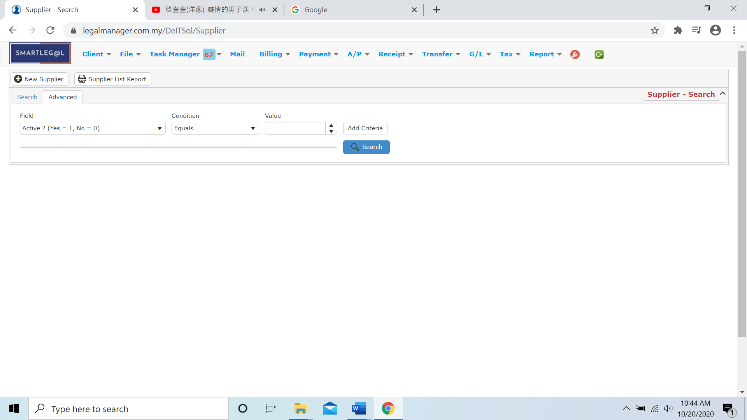

Figure: Manage Supplier – Advanced Search

Note: You can straightly type the Supplier Name to search the supplier

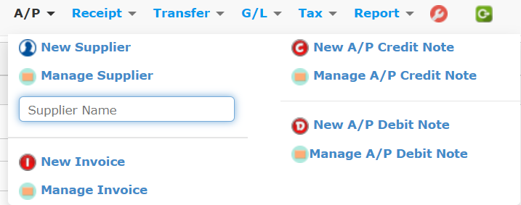

Figure: A/P – Supplier Name

**Searched Result**

* Click ‘**Search**’ once, to show all supplier
* The Searched result will appeal at below, otherwise it will shown no record availble if the quotation you searched do not exist.
* Click ‘**Export**’ to print the desired search results in txt, excel or html format.

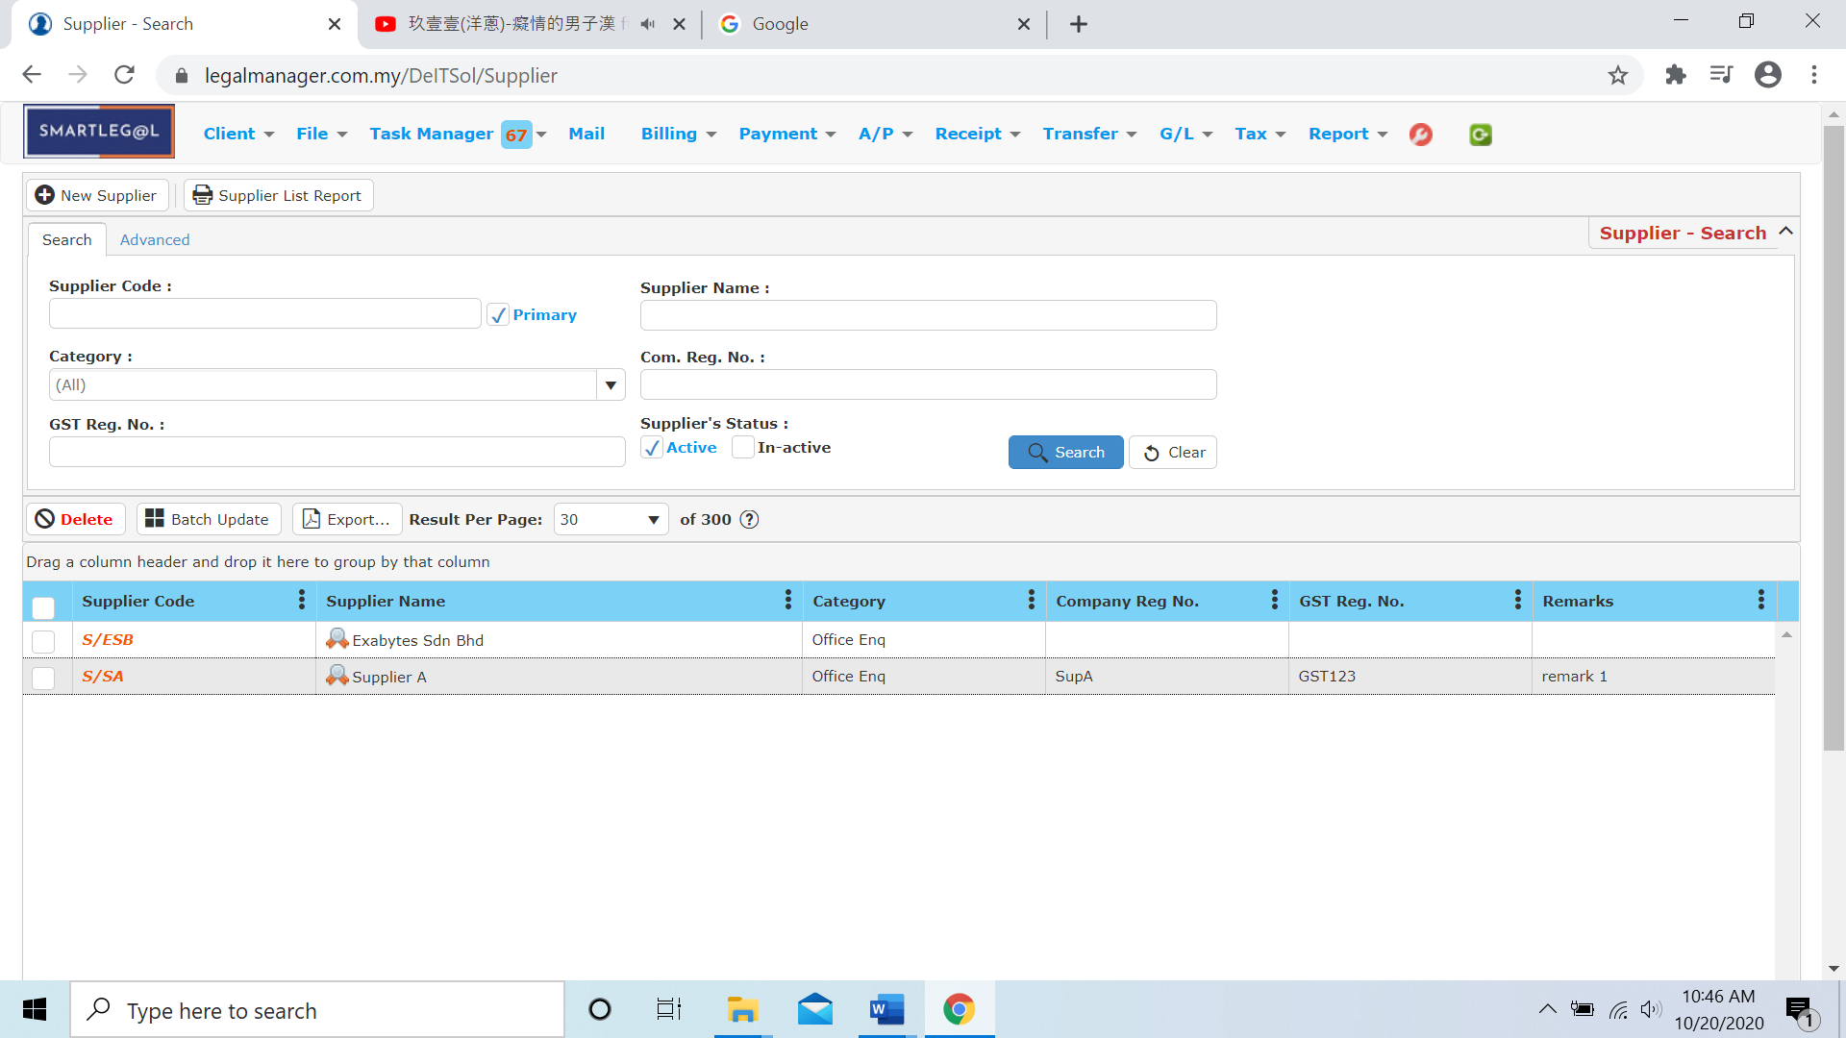

Figure: Manage Spplier – Search All Quotations

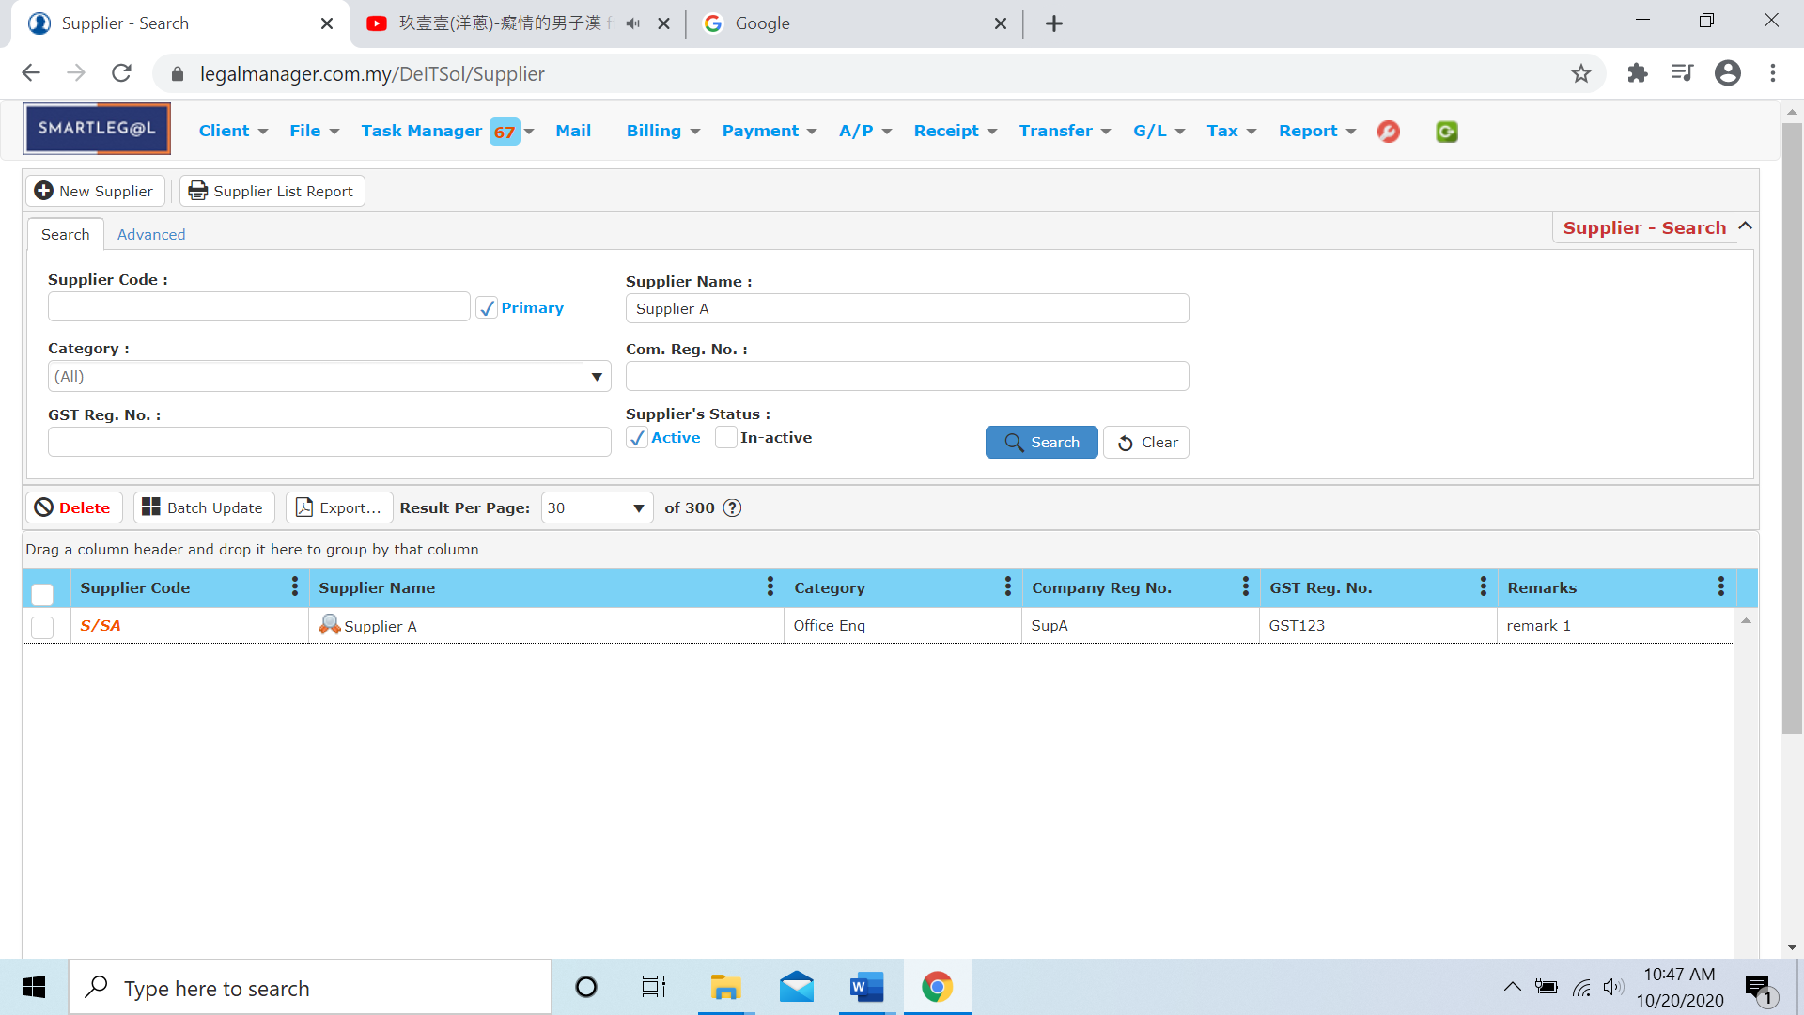

Figure: Manage Supplier – Searched Result

* After the quotation you searched appeal, you can choose to view, edit and preview those details by double-clicking the record.

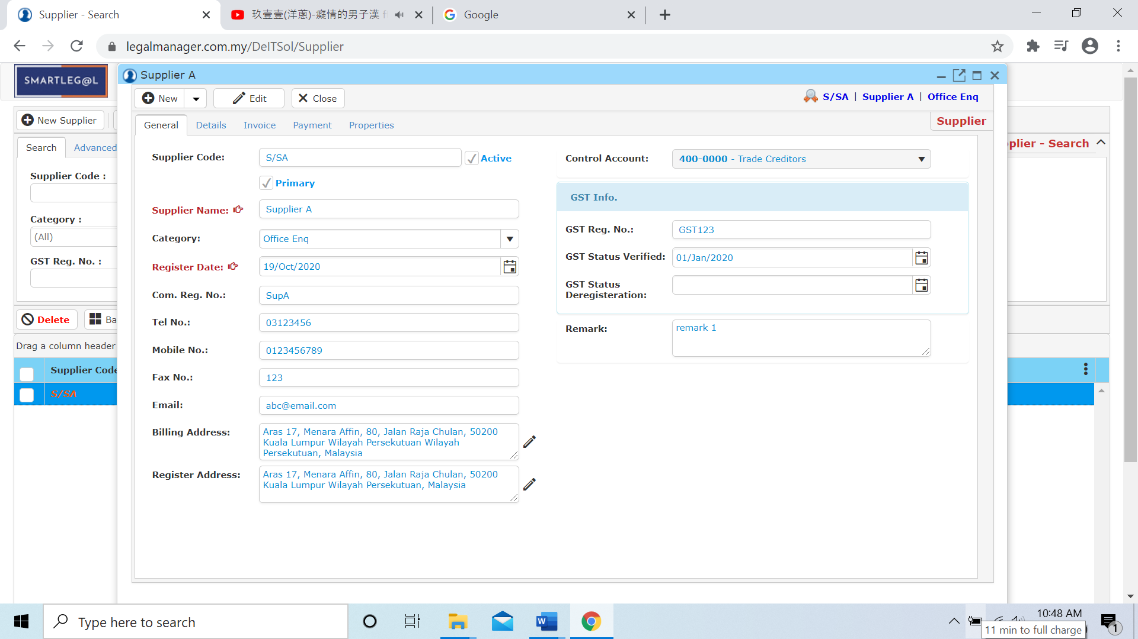

Figure: Manage Supplier – Searched Result, Supplier Info

**7.3 New Invoice**

* To open New Invoice, on the **SmartLeg@l** navigation, click **A/P** and go to **New Invoice**.

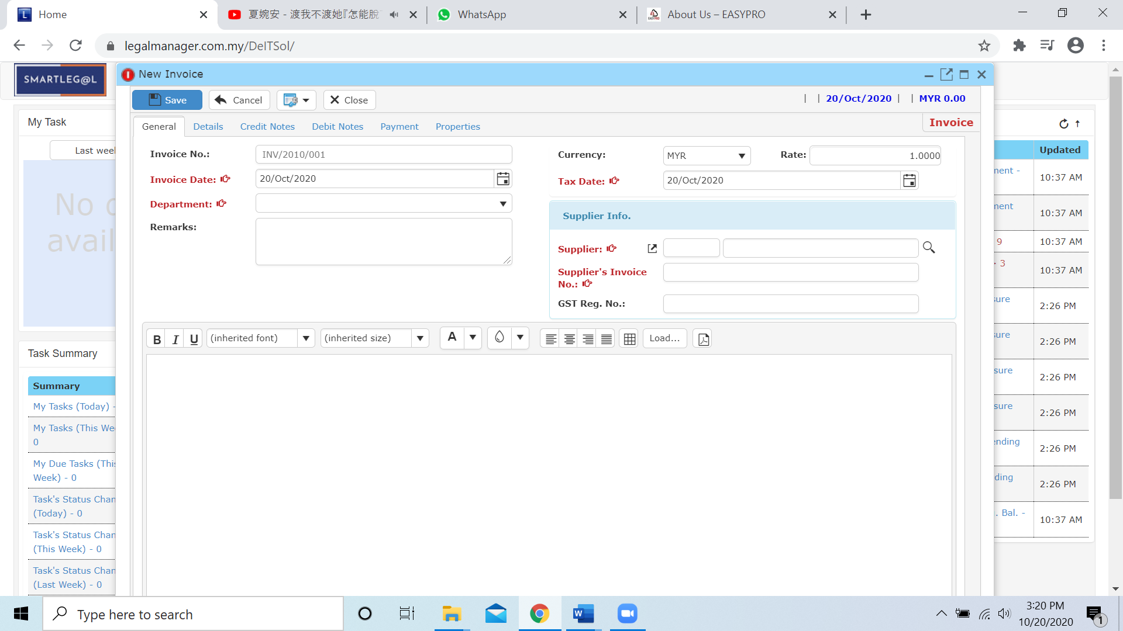

* Invoice Date and Tax Date will auto generated and by default it will be the date you click to new invoice.
* You have to choose department from the combo box

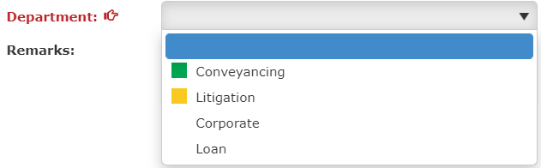

* You can browse supplier by clicking the search icon 

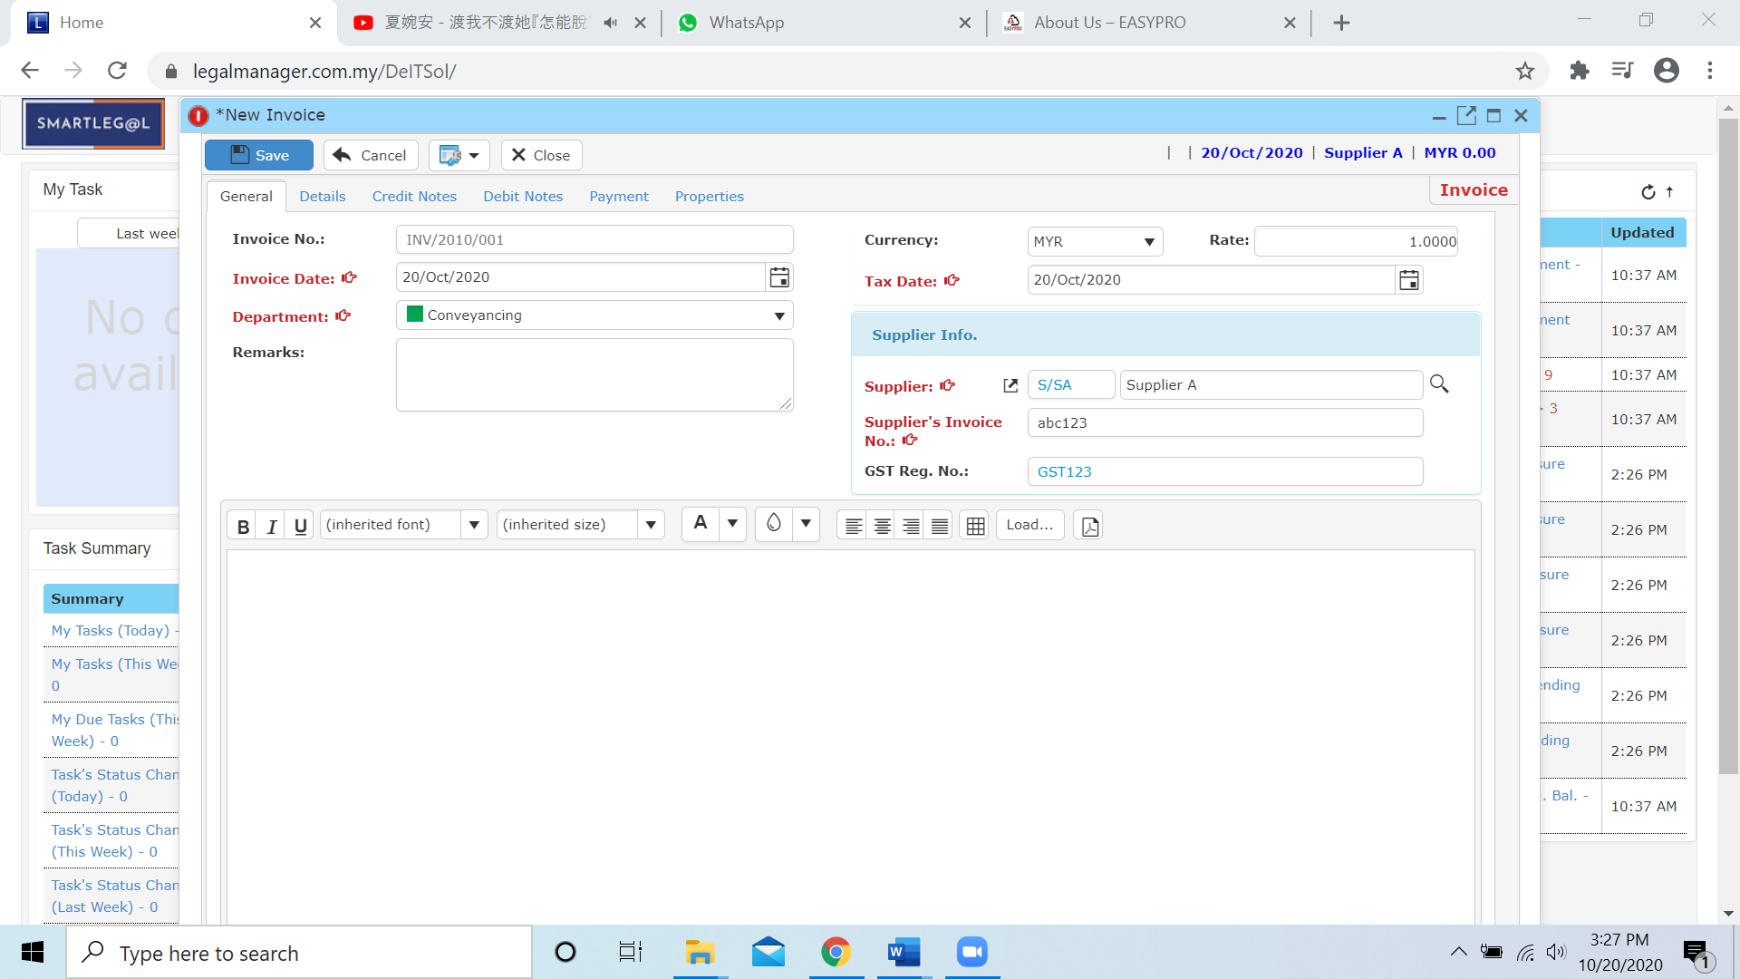

* After you finished filling the general information, please click to next tab ‘Details’

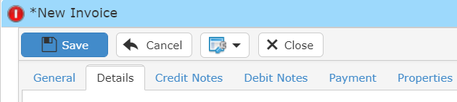

* Once you insert the activity then the debit a/c will auto generate based on the activity you selected or you can select the credit a/c by yourself as well.

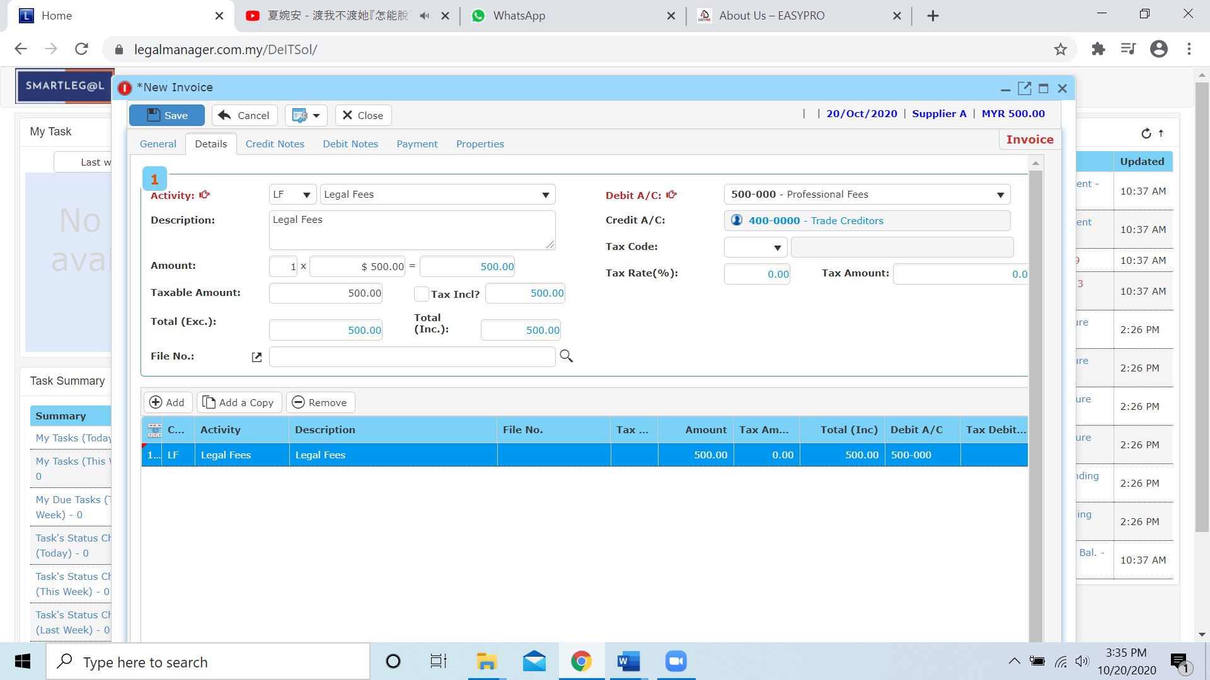

* Other than that, you can Add, Add a Copy or Remove the bill in this section

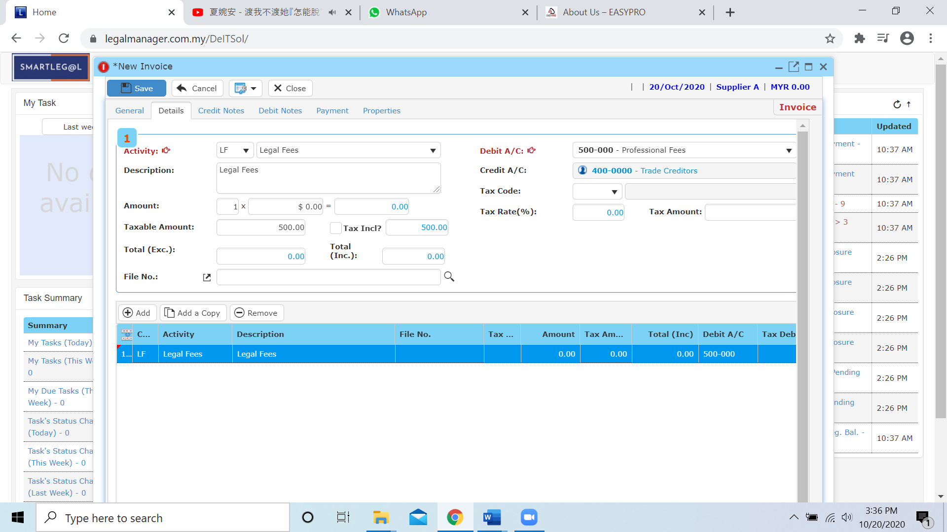

**Add**

* When you click ‘Add’ it will come out a new row and follow the process of above select and key in the activity, dedit a/c and amount.

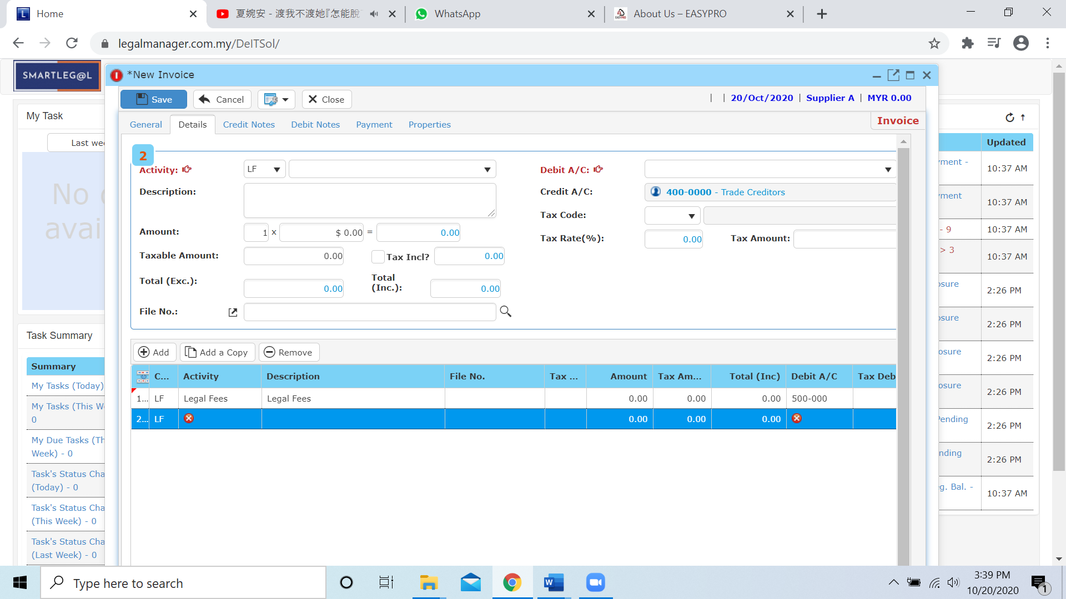

**Add a Copy**

* For Add a Copy, you can duplicate a selected row in the table

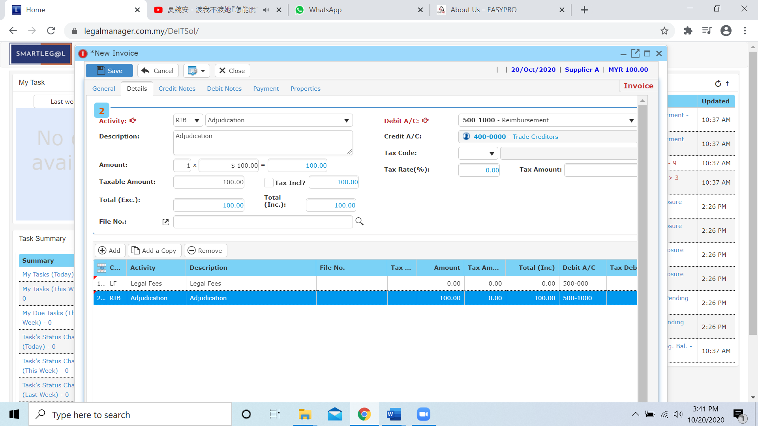

* After you click add a copy, it will copy the row as below figure shown

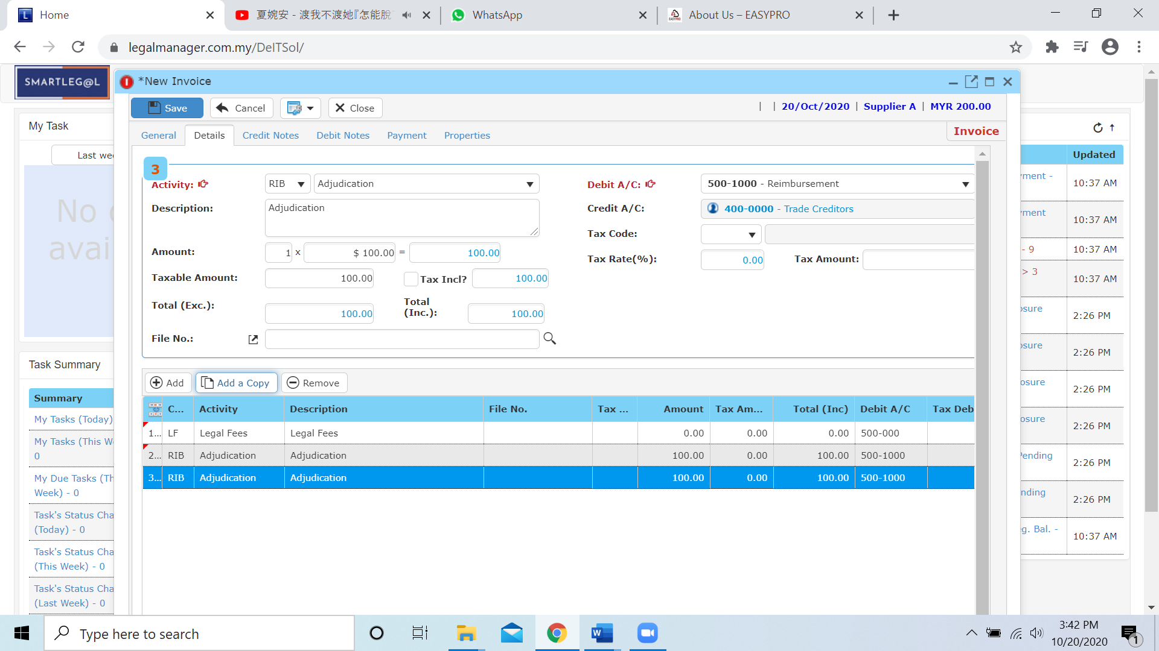

**Remove**

* For the remove, you have to select the bill in the list and click remove to erase the bill



* After you click the remove button it will erase the selected row



* After that you can click to the next tab ‘Credit Note’

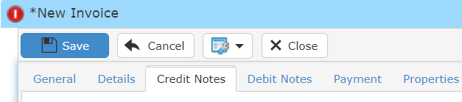

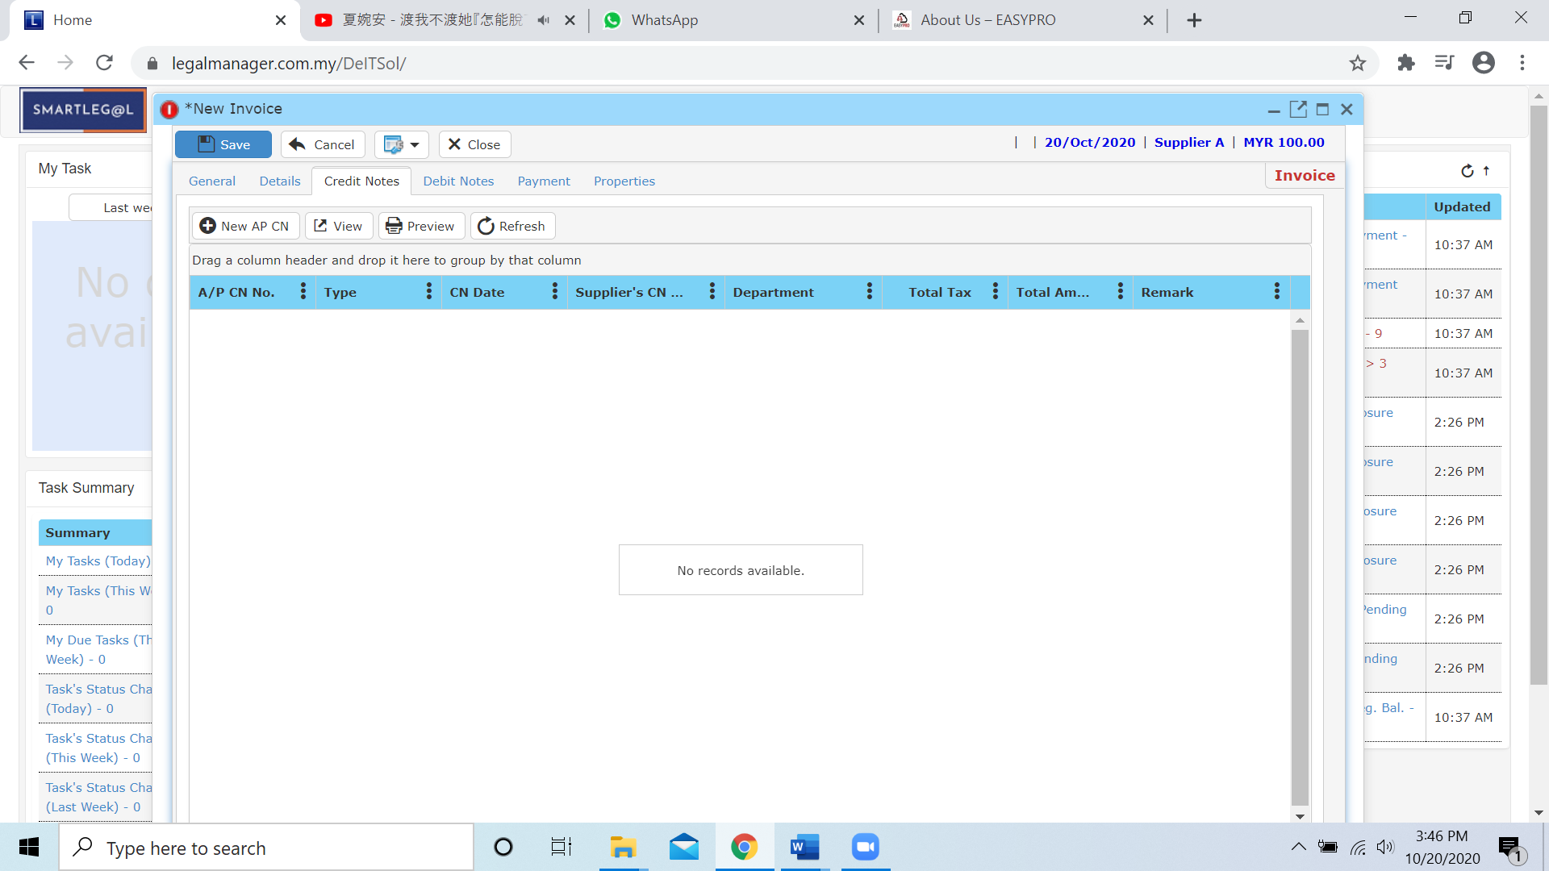

* Credit Note in new invoice you can Add New AP CN by clicking  and you may refer to Chapter 7.5 A/P New Credit Note
* Besides you can you other function like view or preview before print after you create the A/P CN.
* When you click to the next tab ‘Debit Note’

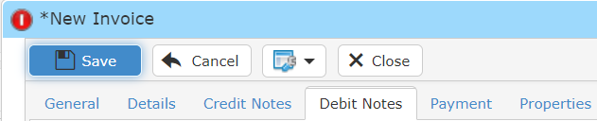

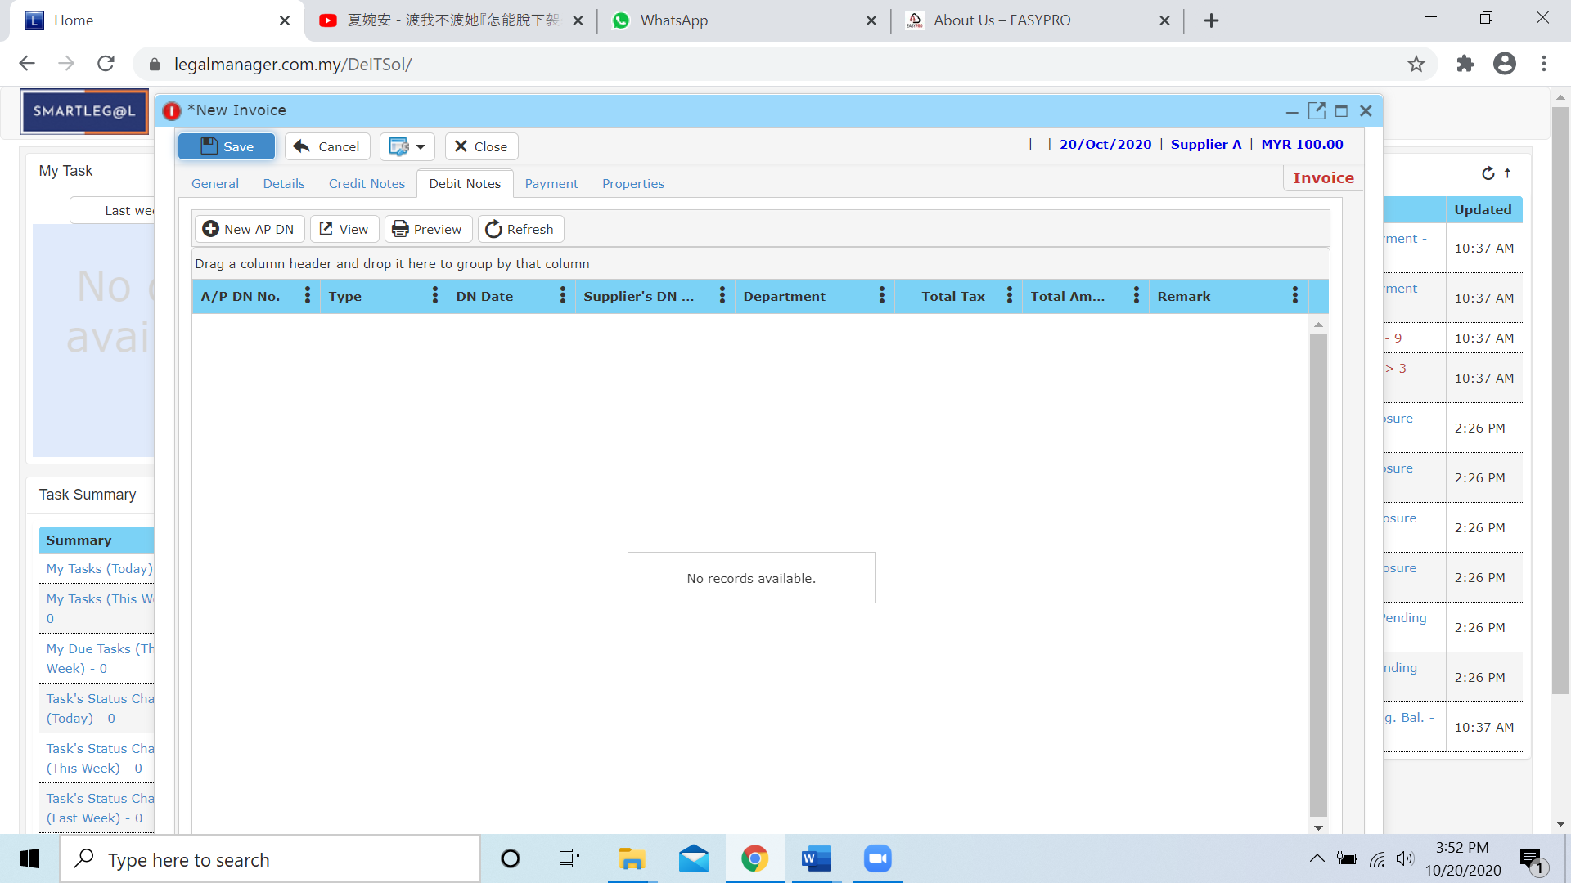

* There are exactly same operate method as A/P CN and you can add A/P DN by clicking  and you may refer to Chapter 7.7 A/P New Debit Note and you can view or preview after you created the A/P DN as well
* Click to the next tab ‘Payment’ Tab

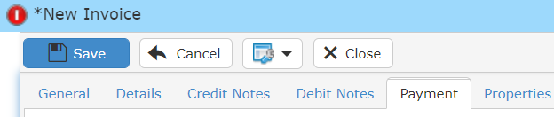

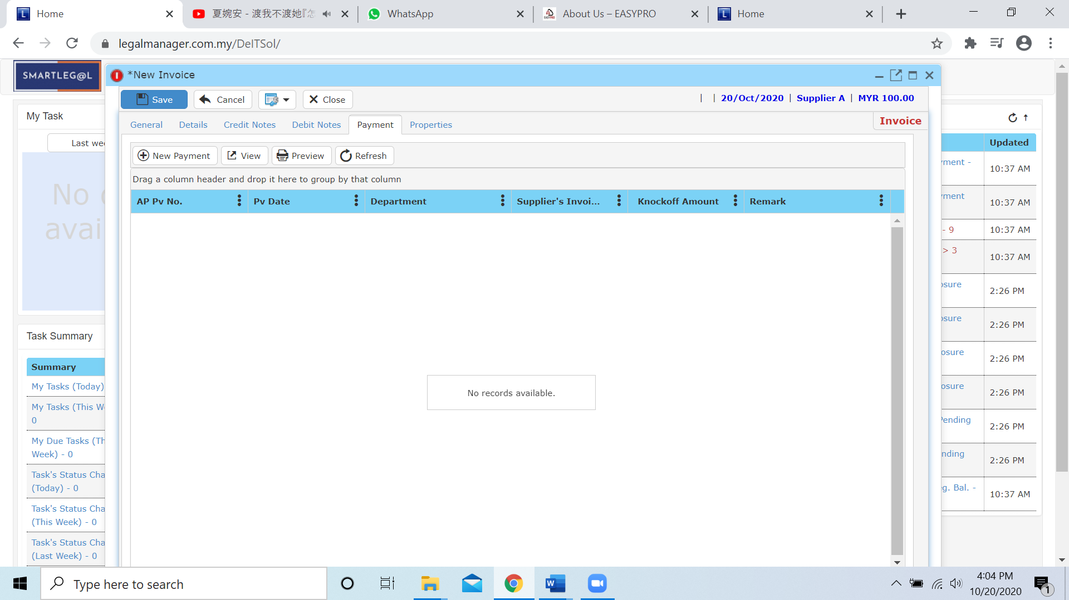

* Payment in new invoice you can Add New Payment by clicking  and you may refer to New A/P Payment
* Besides you can you other function like view or preview before print after you create the payment
* The last tab when you creating a new invoice is ‘Properties’

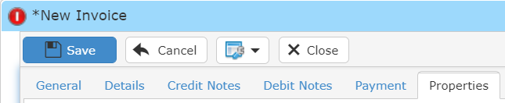

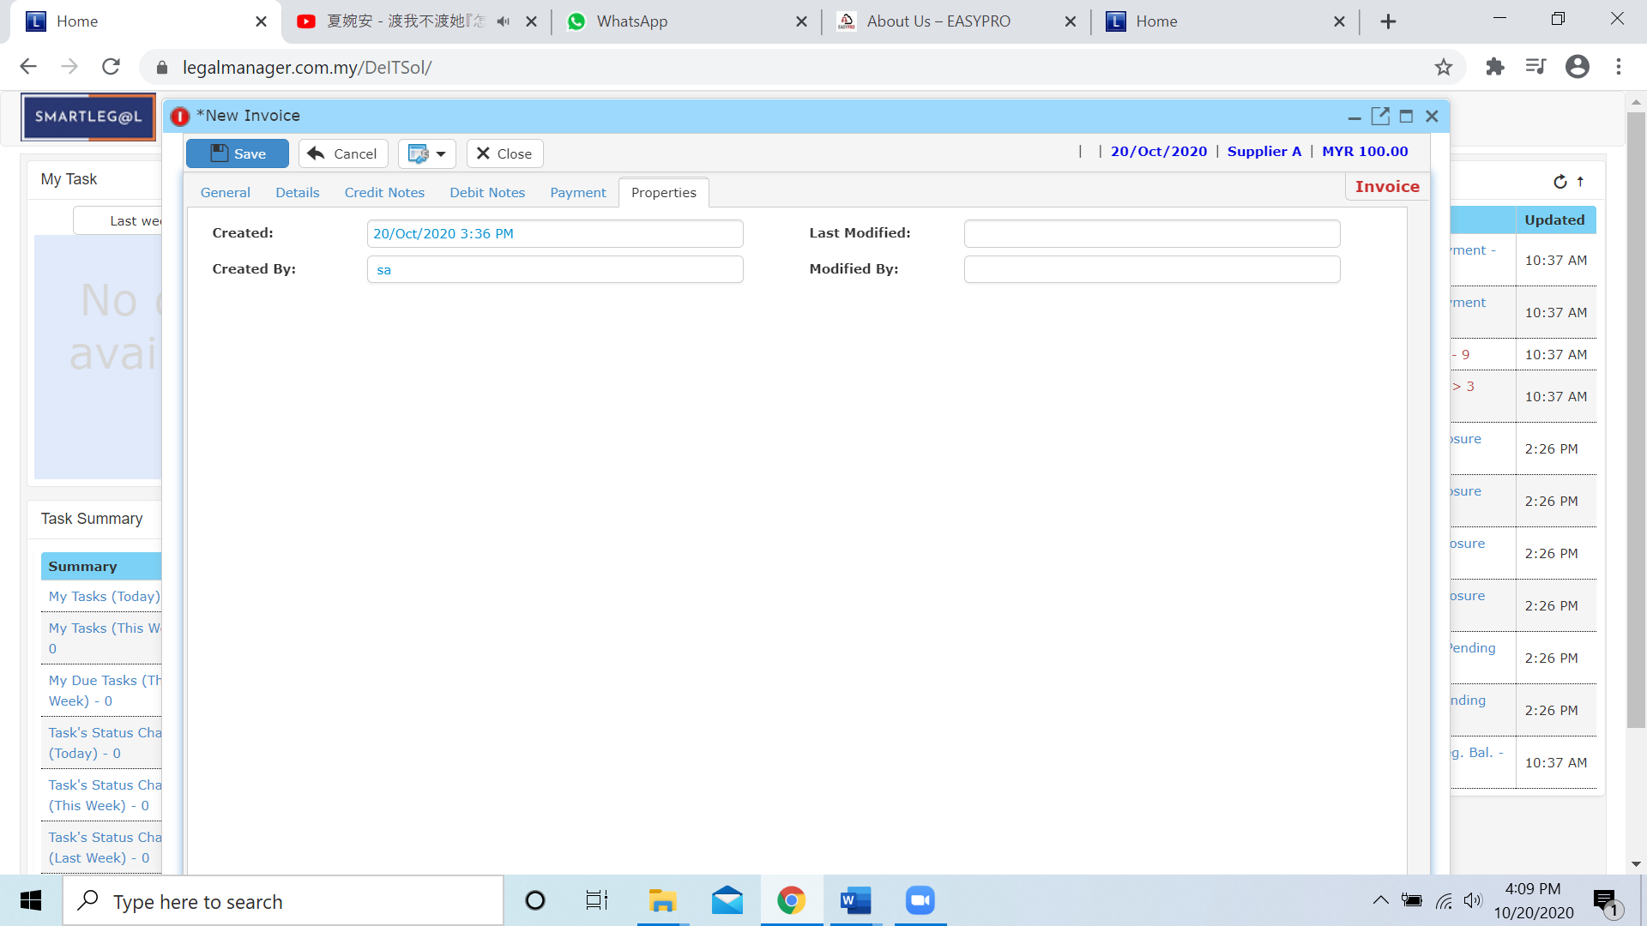

* You can view the information of the invoice once who modify the invoice then there will show the last modified and modified by who
* Once you finish all the instruction above, click ‘Save’ then you are done to create a new invoice.

**7.4 Manage Invoice**

This option enables you to add, edit, and delete an Invoice. It also allows you to keep track of your invoice details and all related information.

* To open Manage Invoice, on the **SmartLeg@l** navigation, click **A/P** and go to **Manage Invoice** then search the invoice you wish to modify.

**Manage Invoice**

* Search the invoice you wish to manage through type the search criteria or search by advanced.
* To start a new search or to clear the search results, click ‘**Clear**’.

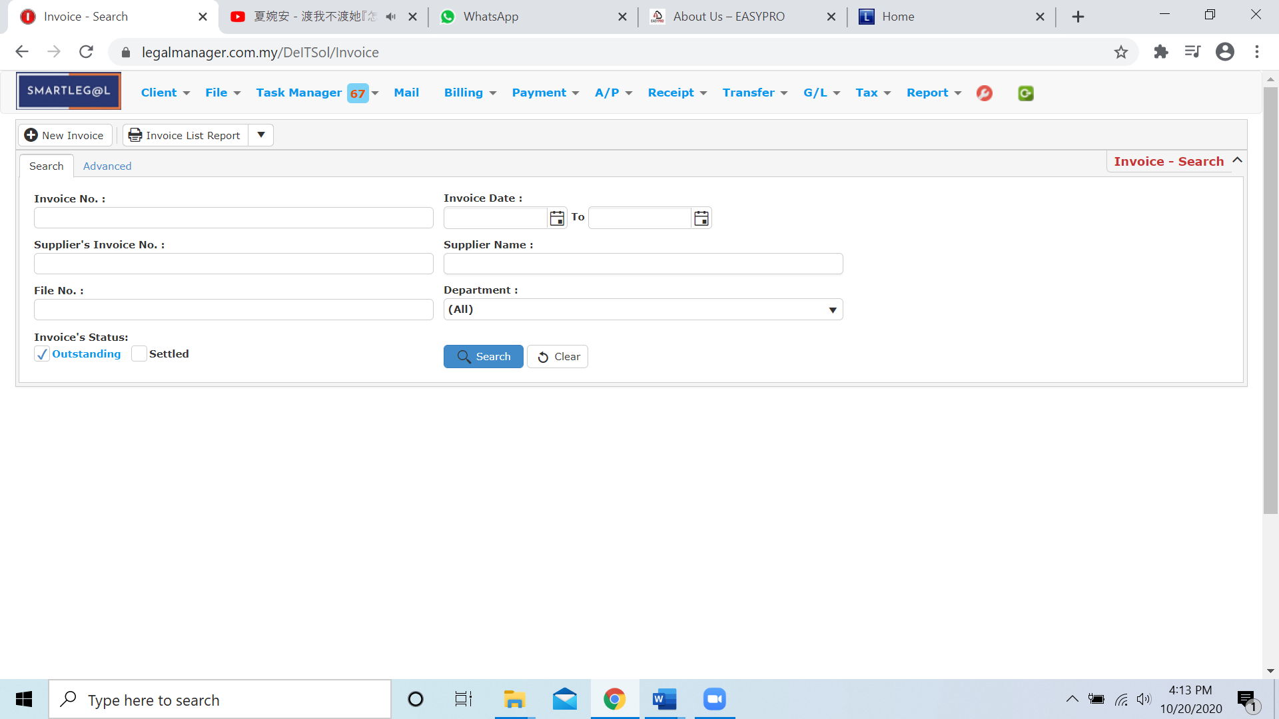

Figure: Manage Invoice - Search

**Advanced Search**

* This function can be used to find a invoice by searching other information that is not captured in the ‘General’ section.
* Define search criteria:

**- Field** - Choose the field you want to search.

**- Condition** - Search condition

**- Value** - Type in the detail you want to find.

* Click ‘**Add to list**’, to define more than one criteria.
* Click ‘**Find**’, search results will be displayed at search record list. You can open an item in the search results list by double-clicking.
* To start a new search or to clear the search results, click ‘**Clear**’.
* Click ‘**Export**’ to print the desired search results in txt, excel or html format.

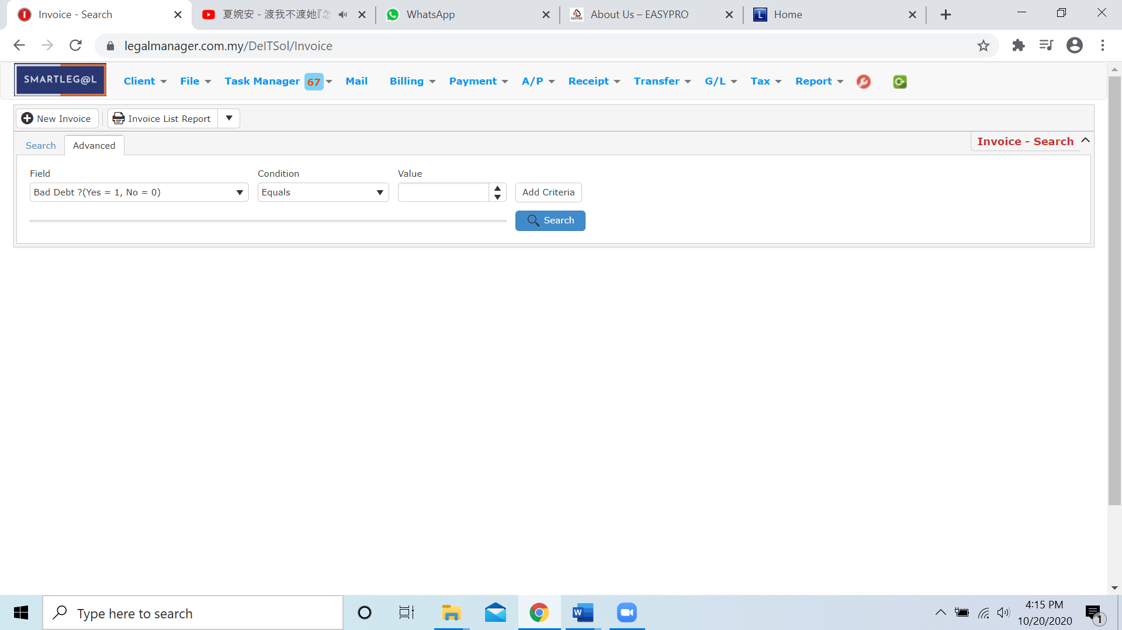

Figure: Manage Invoice– Advanced Search

* You can choose to create a new past bill by click  and refer to ‘Chapter 7.3 New Invoice’
* You can print or preview the Past Bill List Report while you click to 
* Then it will pop-up a Past Bill List Report you can insert your requirement and filter the report

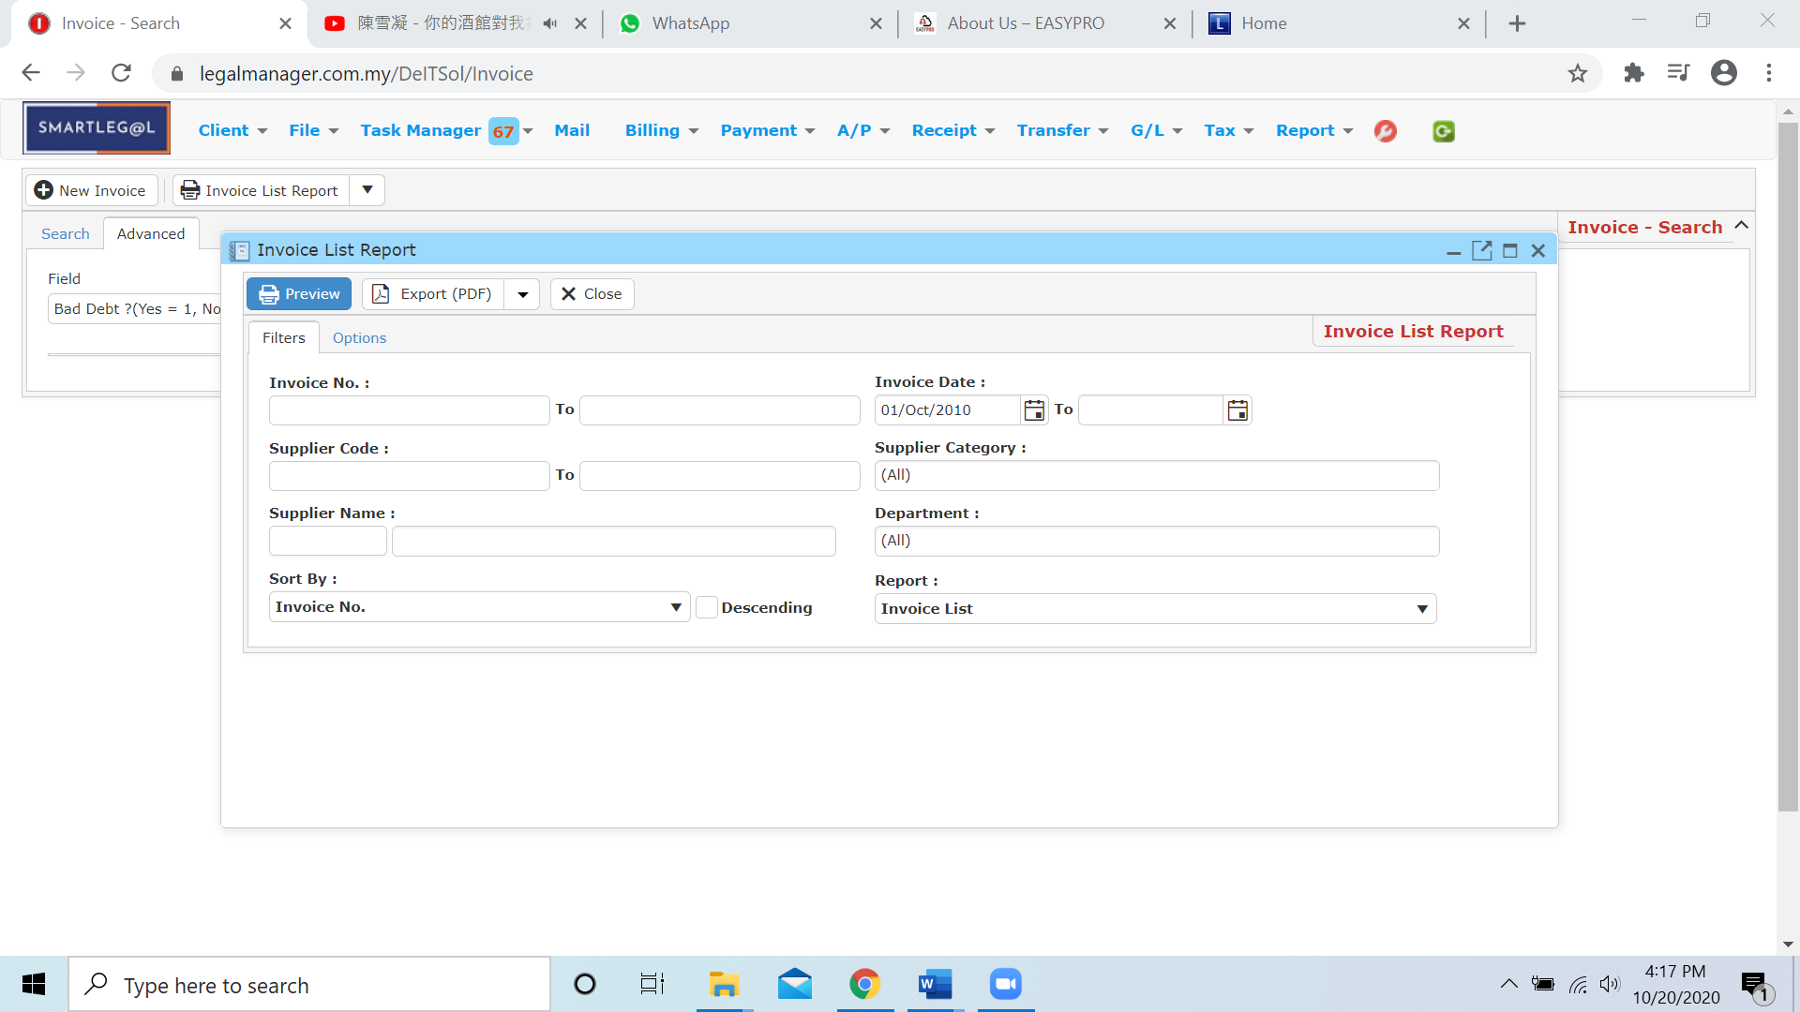

* Besides, you can preview the report as figure below shown

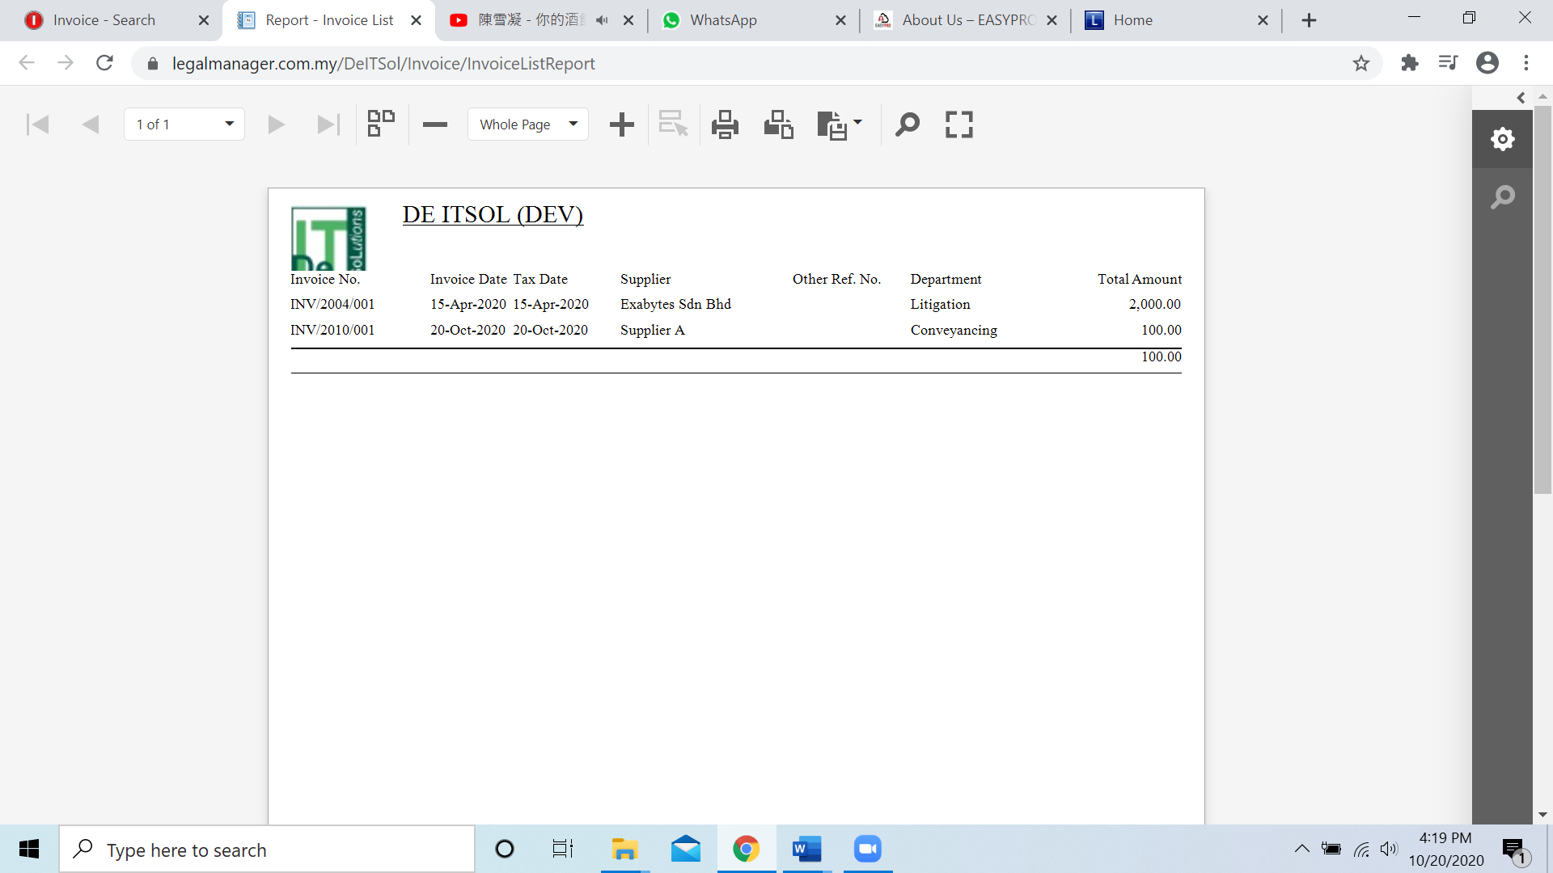

* You can also export the report into PDF or excel by clicking

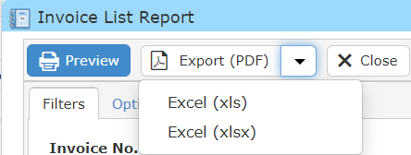

**Searched Result**

* Click ‘**Search**’ once, to show all Invoice Note Record
* The Searched result will appeal at below, otherwise it will shown no record availble if the quotation you searched do not exist.
* Click ‘**Export**’ to print the desired search results in txt, excel or html format.

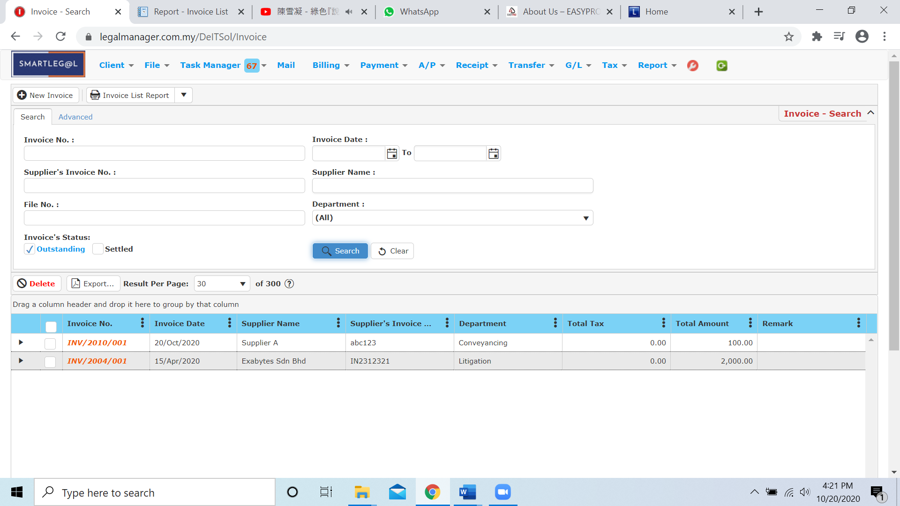

Figure: Manage Invoice – Search All

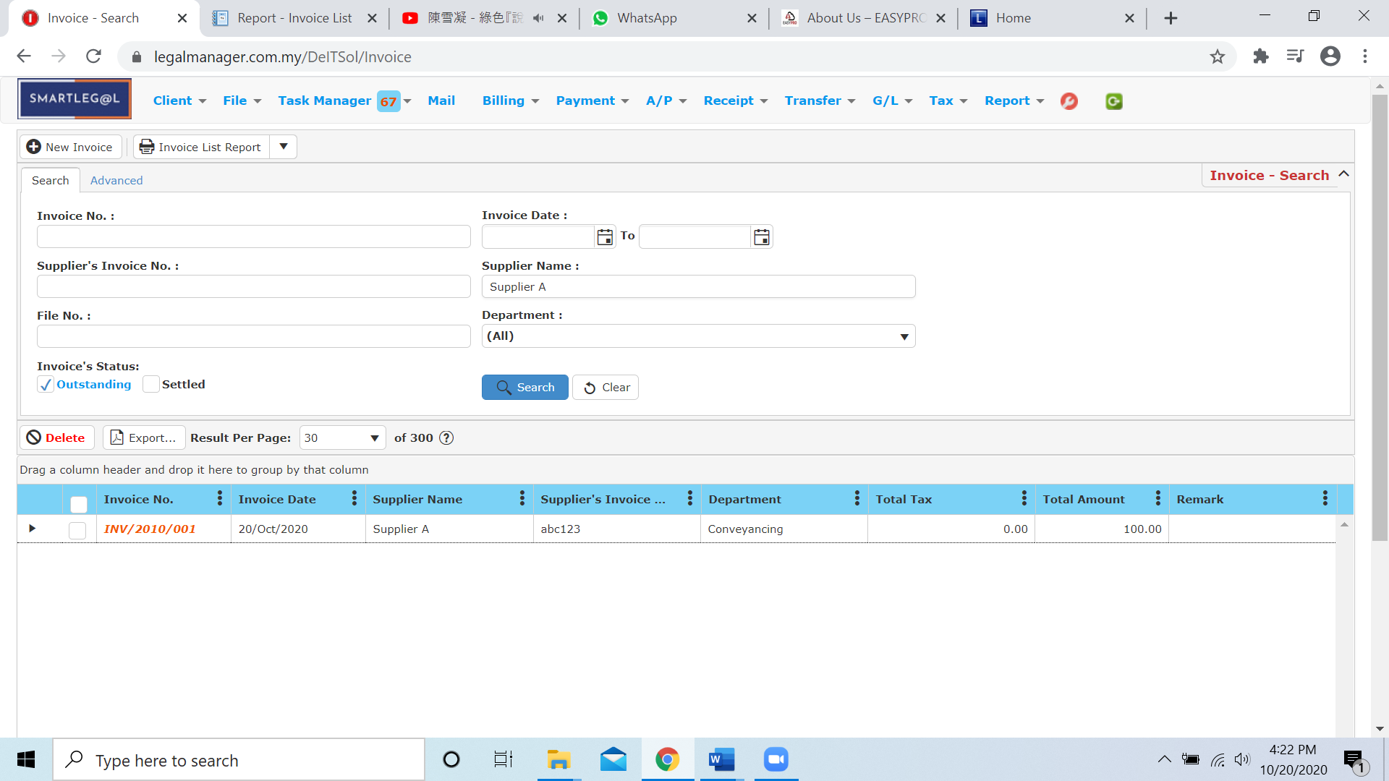

Figure: Manage Invoice – Searched Result

* After the Invoice record you searched appeal, you can choose to view, edit and preview those details by double-clicking the record.

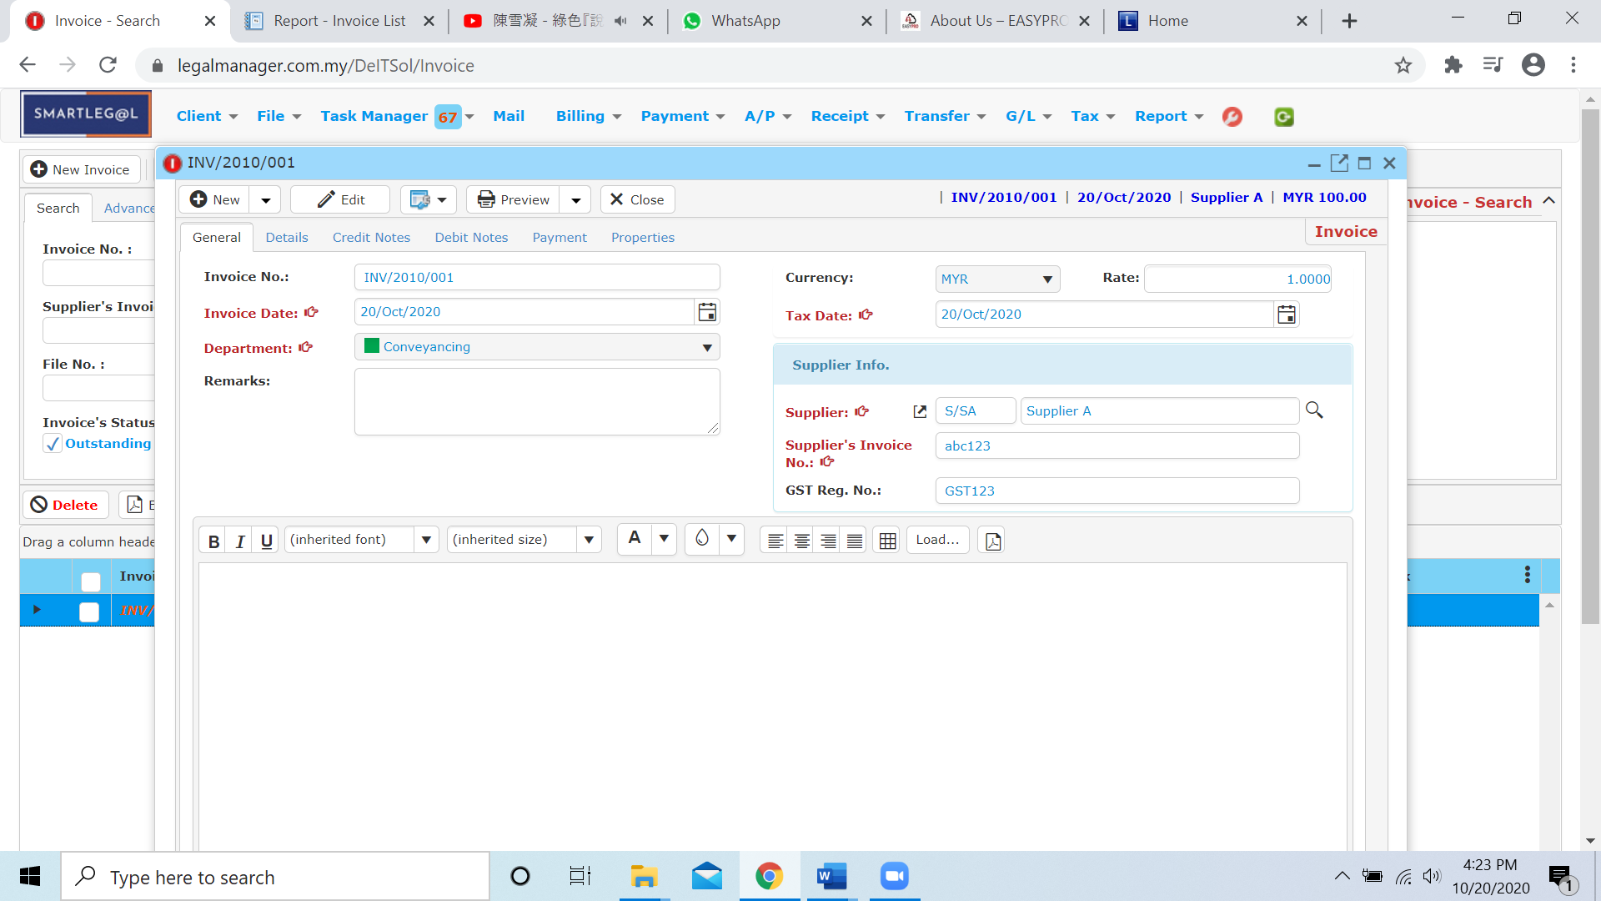

Figure: Manage Invoice – Searched Result, Info

**7.5 New A/P Credit Note**

* To open New A/P Credit Note, on the **SmartLeg@l** navigation, click **A/P** and go to **New A/P Credit Note**.

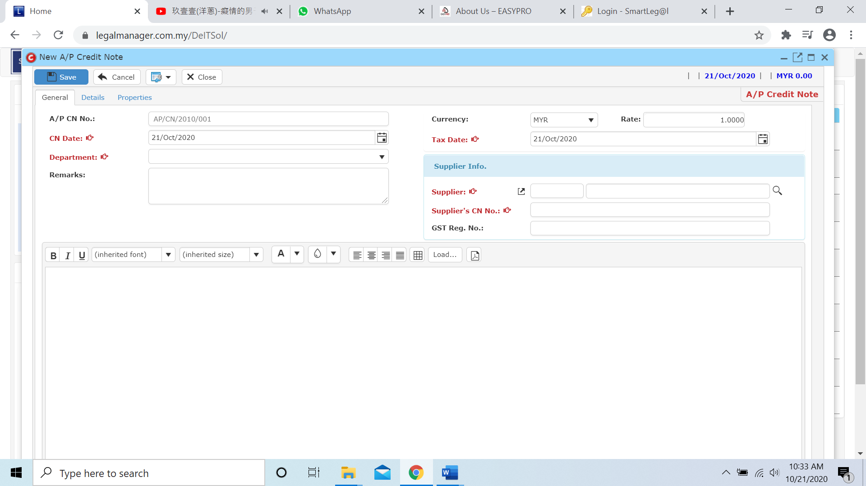

* Select C/N date, Department and Tax Date
* Click  icon to browse your supplier

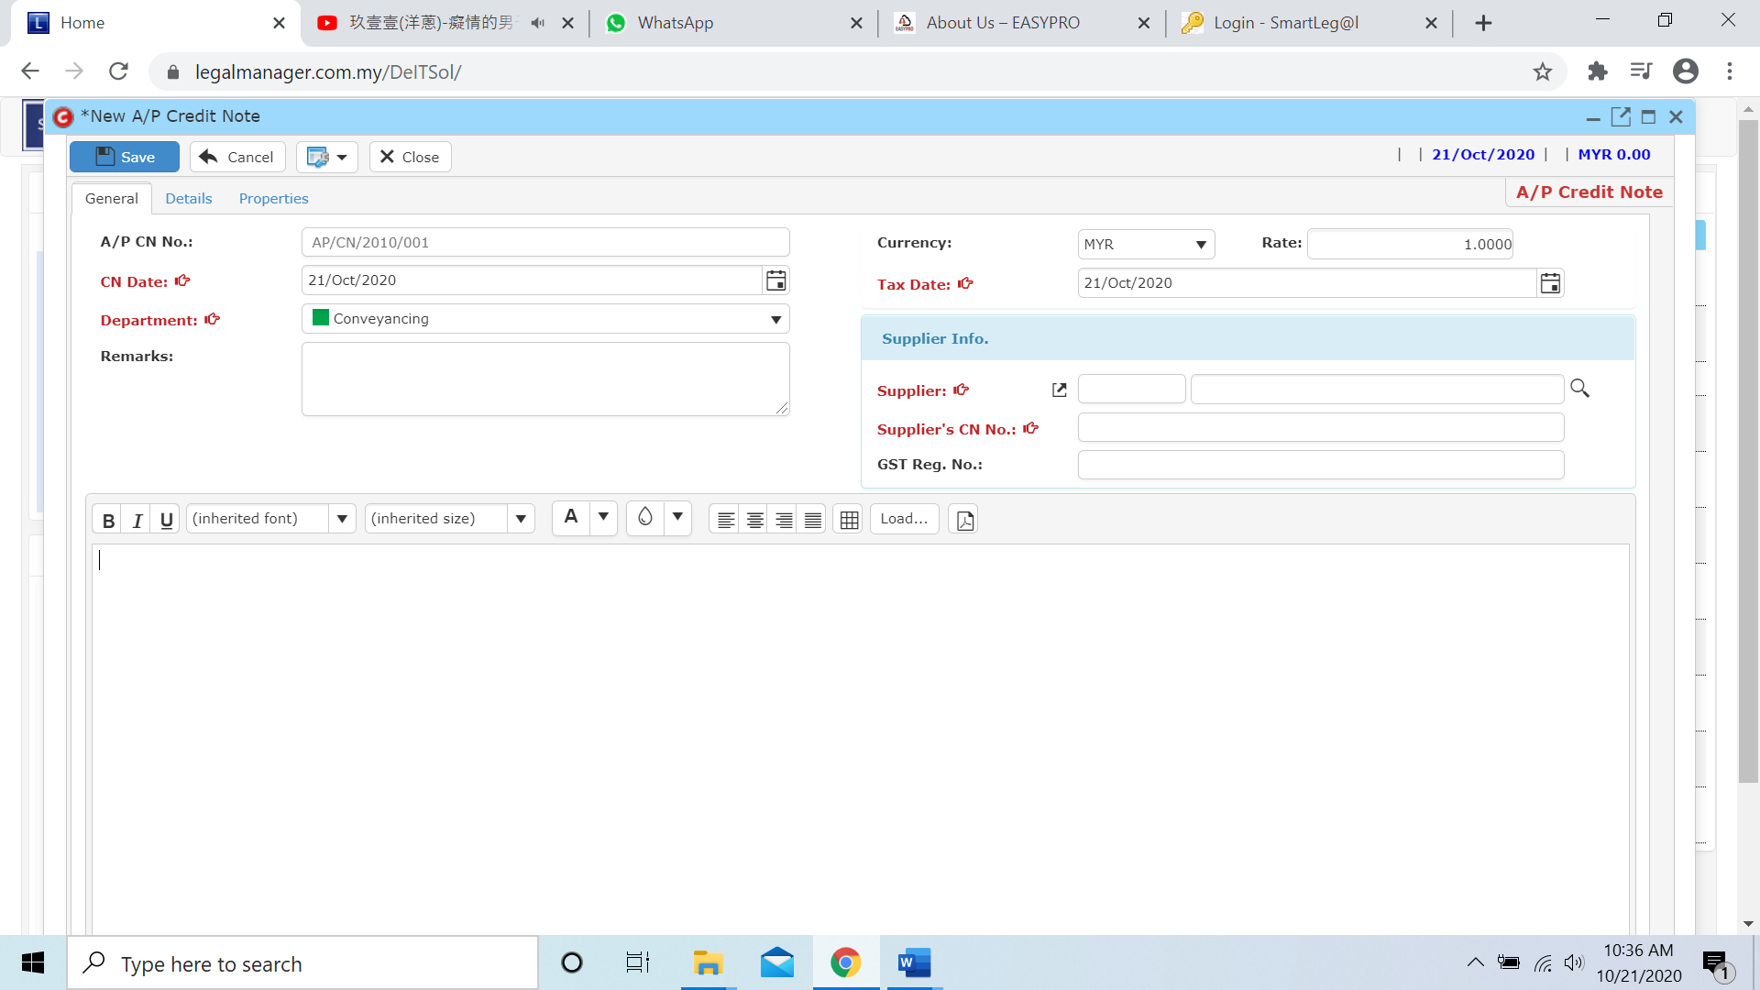

* The Search Supplier will pop up as figure below shown and click ‘Search’ once to show all suppliers

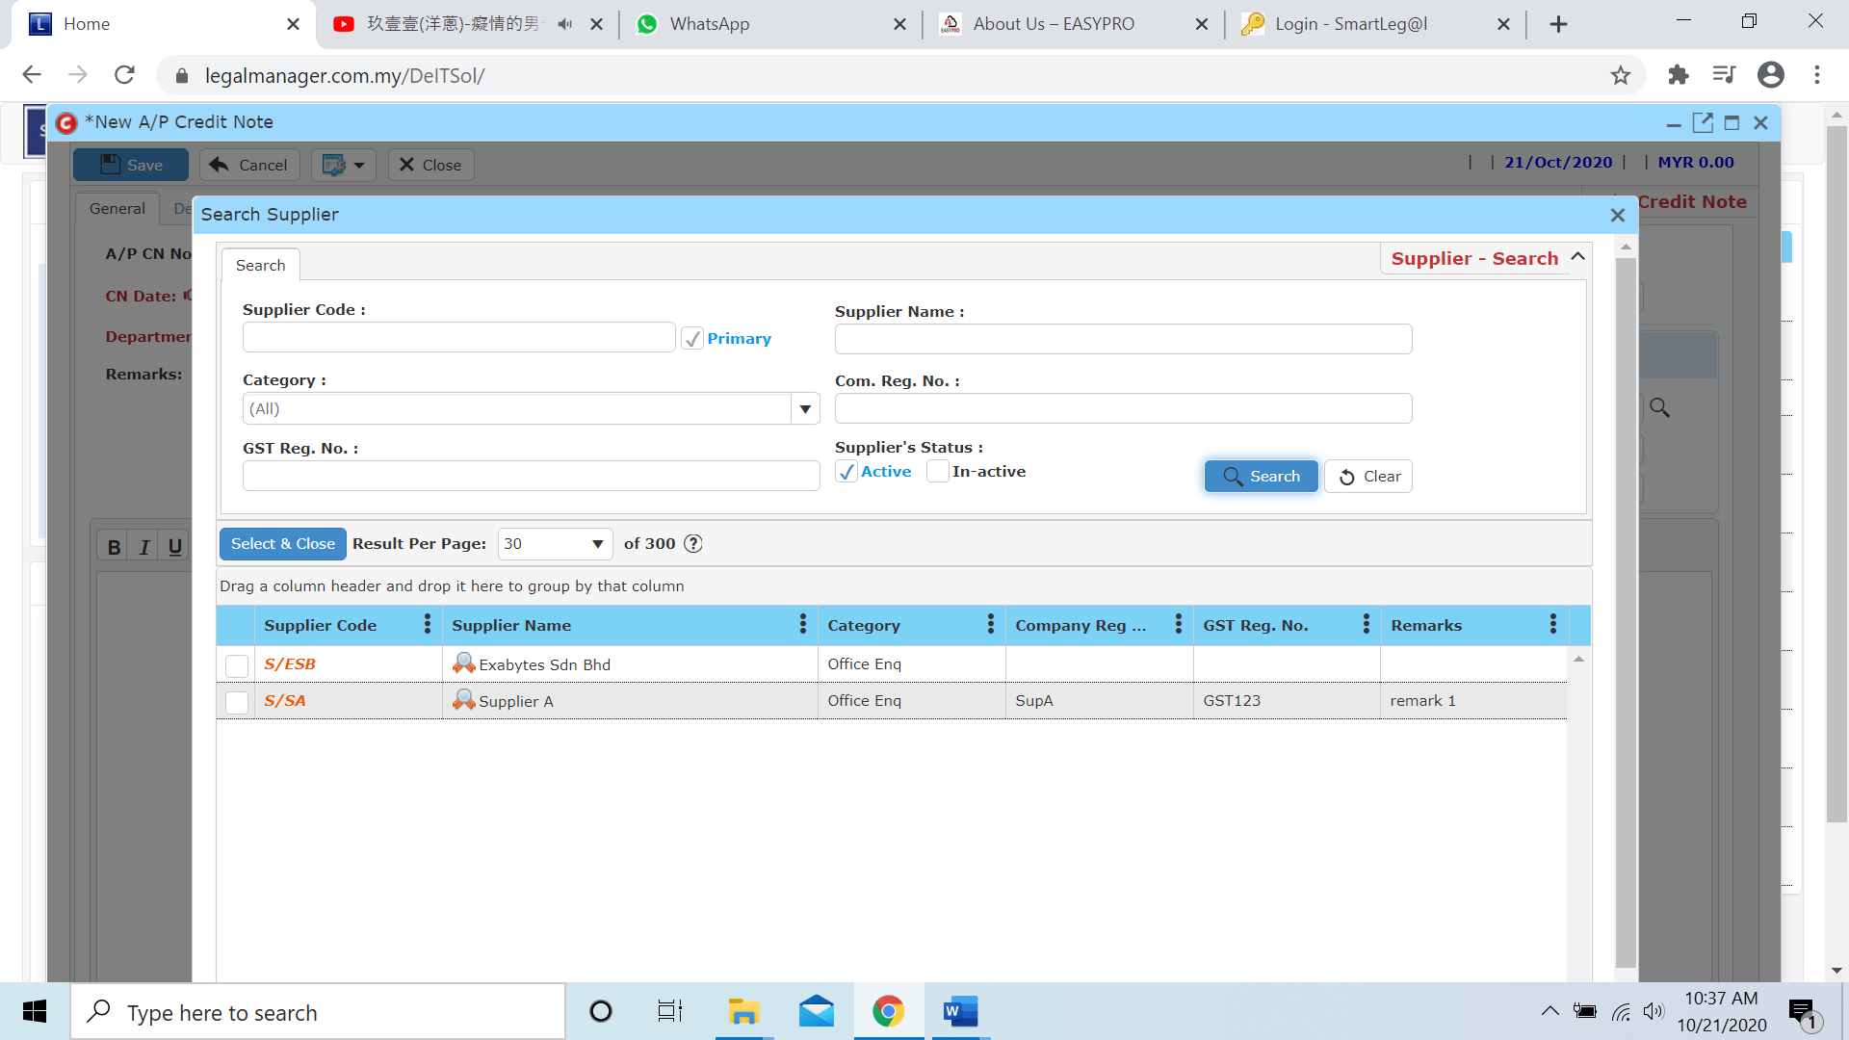

* Click to next tab ‘Details’

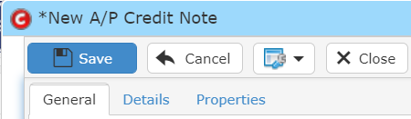

* While you click to details tab, it will auto pop up a search invoice for the supplier you selected
* Click search to your supplier’s invoice

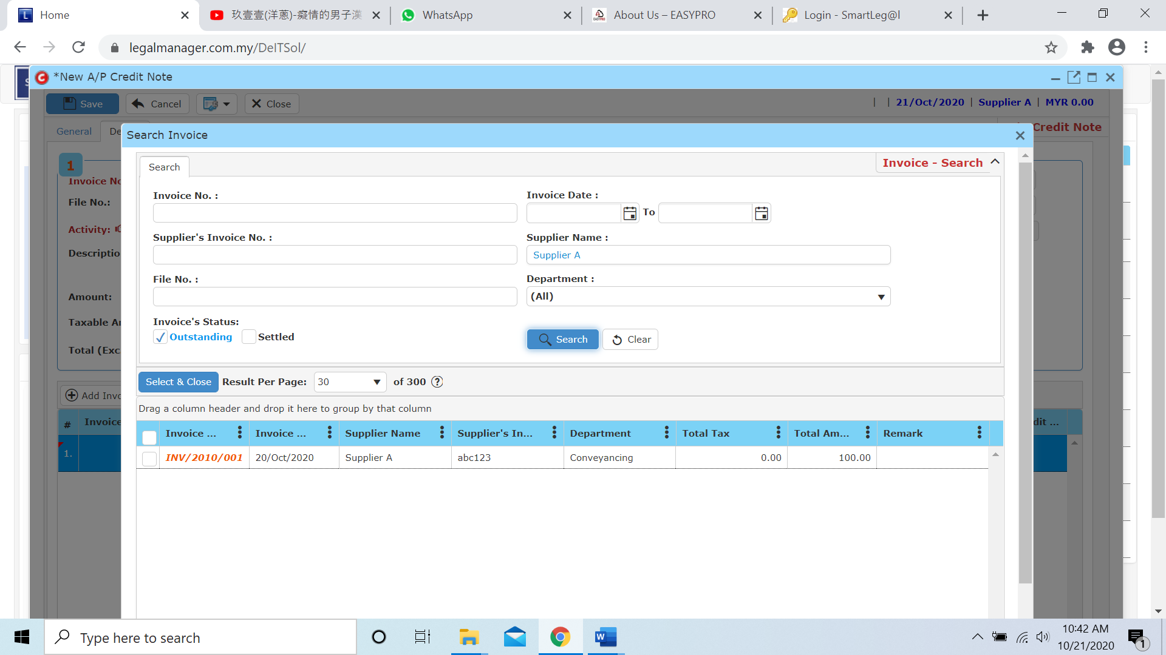

* Once you insert the activity then the credit a/c will auto generate based on the activity you selected or you can select the credit a/c by yourself as well.

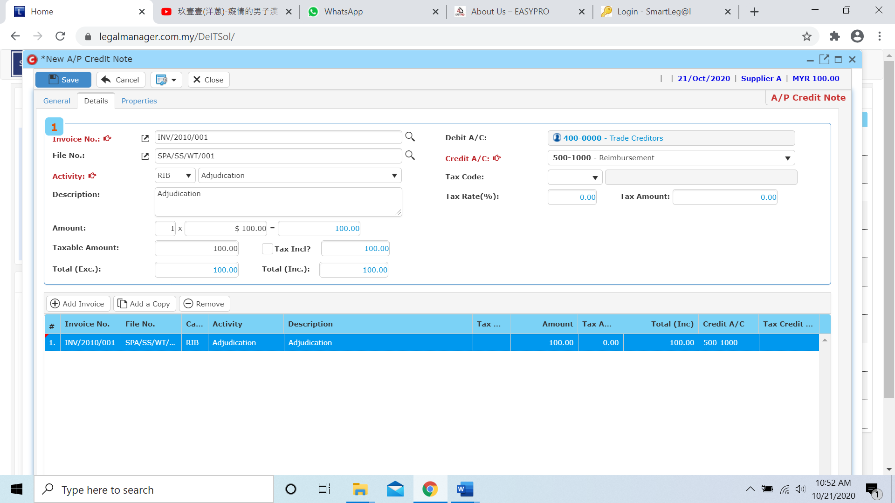

* Other than that, you can Add, Add a Copy or Remove the bill in this section



**Add Invoice**

* When you click ‘Add Invoice’ it will pop up the search invoice above and follow the process of above select and key in the activity, debit a/c and amount.

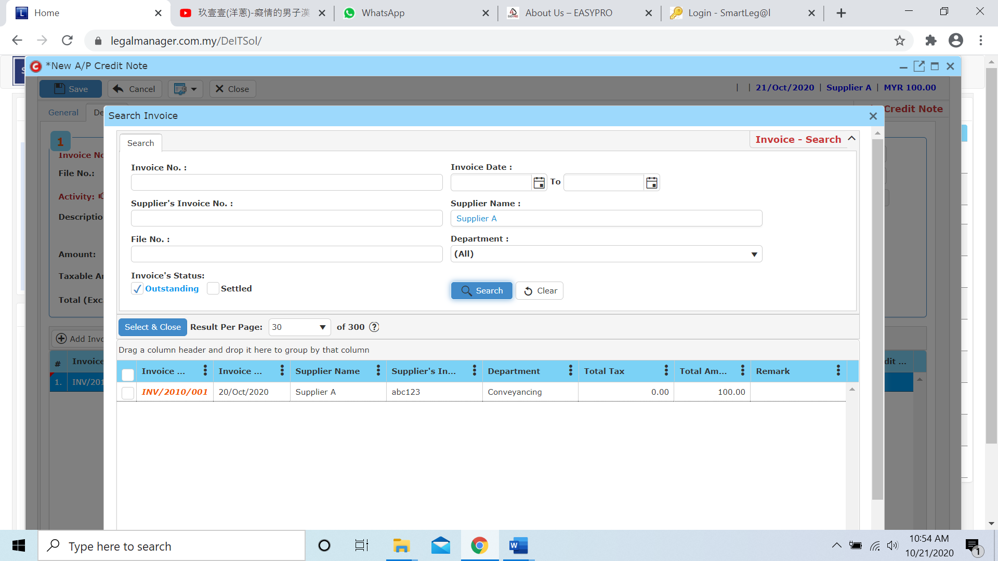

**Add a Copy**

* For Add a Copy, you can duplicate a selected row in the table

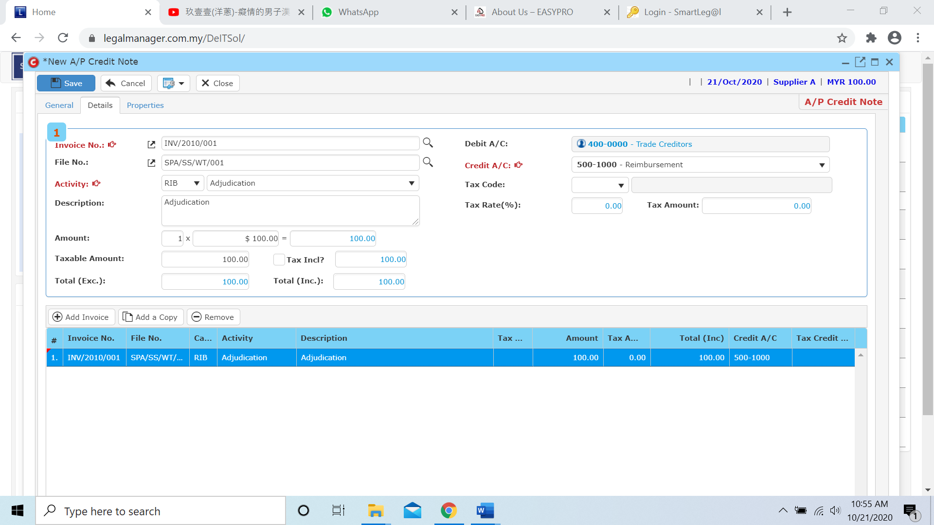

* After you click add a copy, it will copy the row as below figure shown and you can insert the activity and amount again

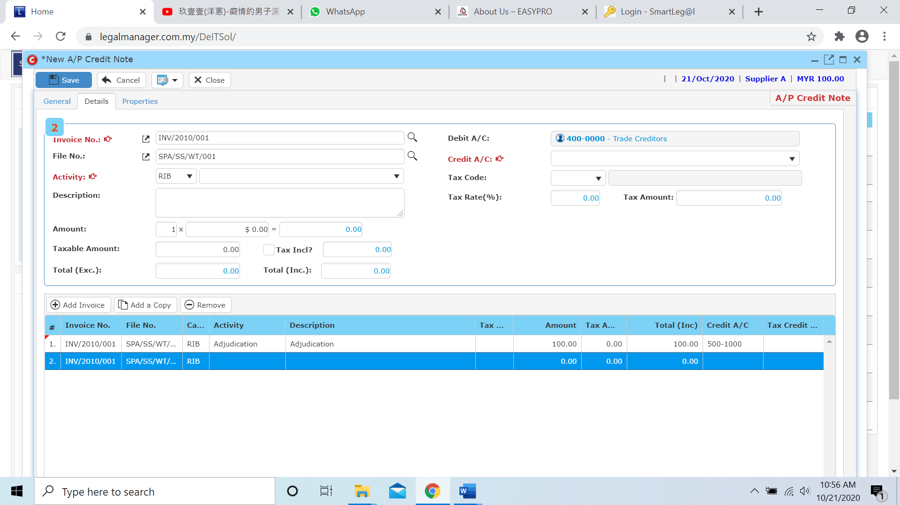

**Remove**

* For the remove, you have to select the bill in the list and click remove to erase the bill

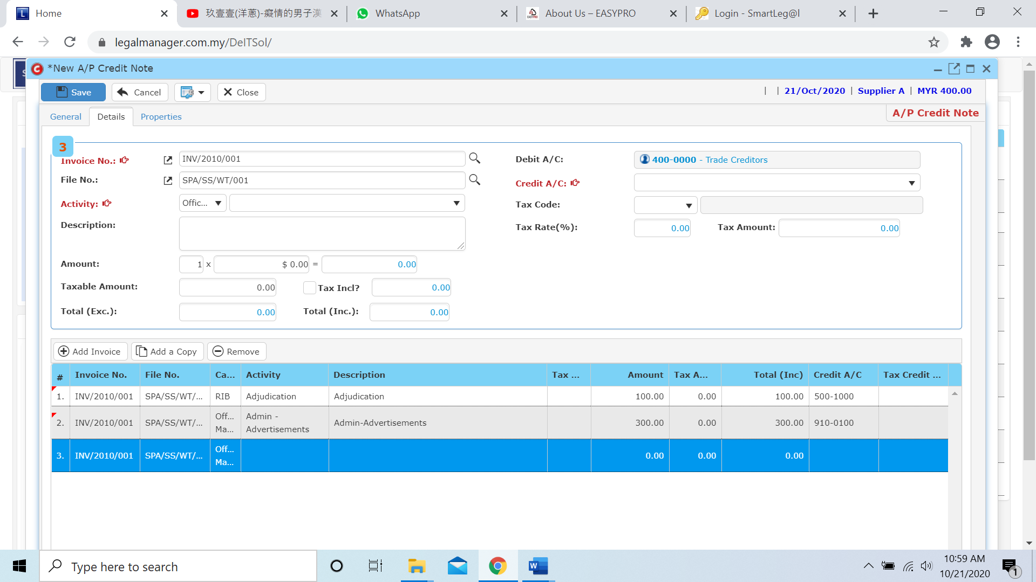

* After you click the remove button it will erase the selected row

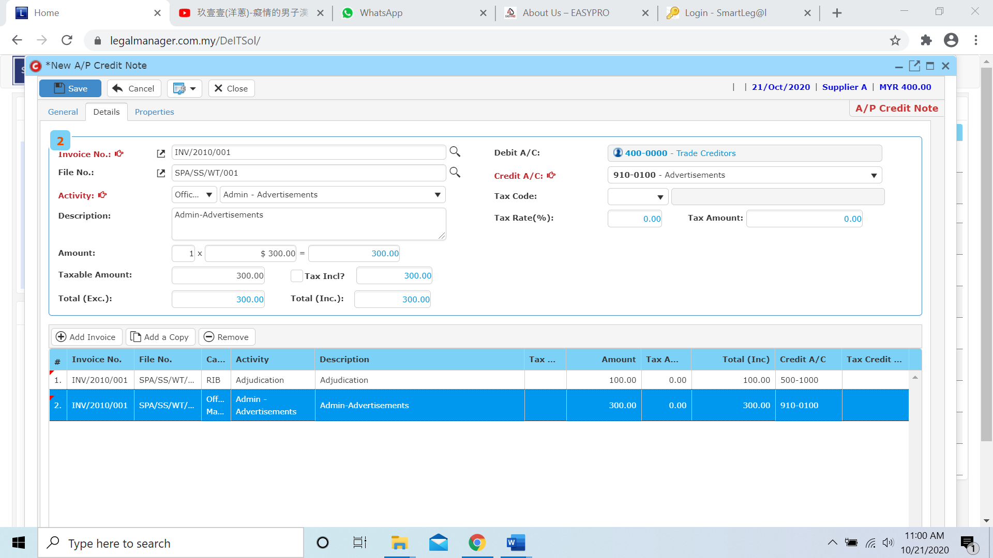

* Click to the next tab ‘Properties’

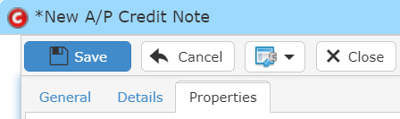

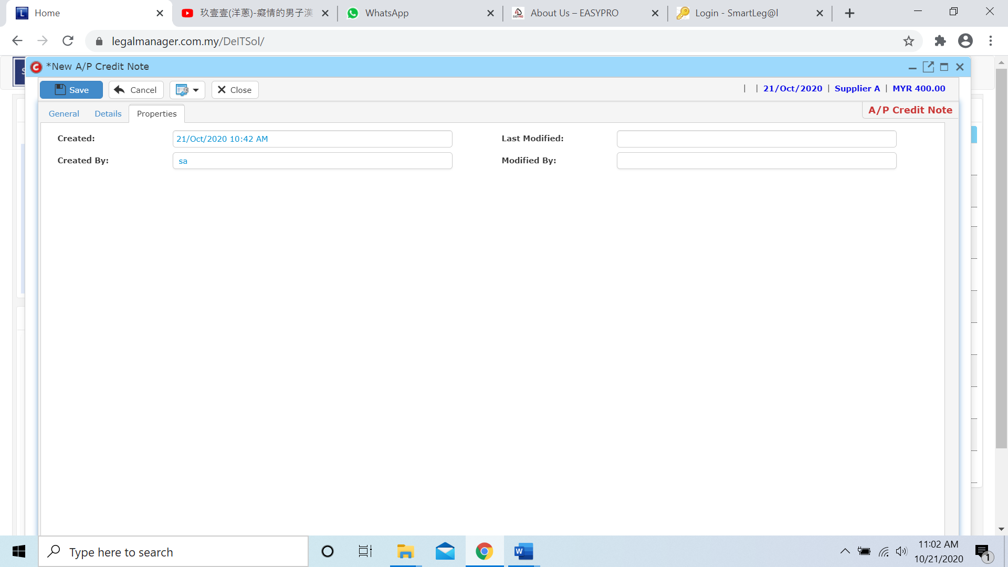

* After you finish insert all the information and details click ‘Save’
* You can view the information of the supplier once who modify the A/P Credit Note then there will show the last modified and modified by who

**7.6 Manage A/P Credit Note**

This option enables you to add, edit, and delete a A/P Credit Note Record. It also allows you to keep track of your A/P Credit Note record details and all related information.

* To open Manage A/P Credit Note, on the **SmartLeg@l** navigation, click **A/P** and go to **Manage A/P Credit Note** then search the A/P Credit Note record you wish to modify.

**Manage A/P Credit Note**

* Search the A/P Credit Note record you wish to manage through type the search criteria or search by advanced.
* To start a new search or to clear the search results, click ‘**Clear**’.

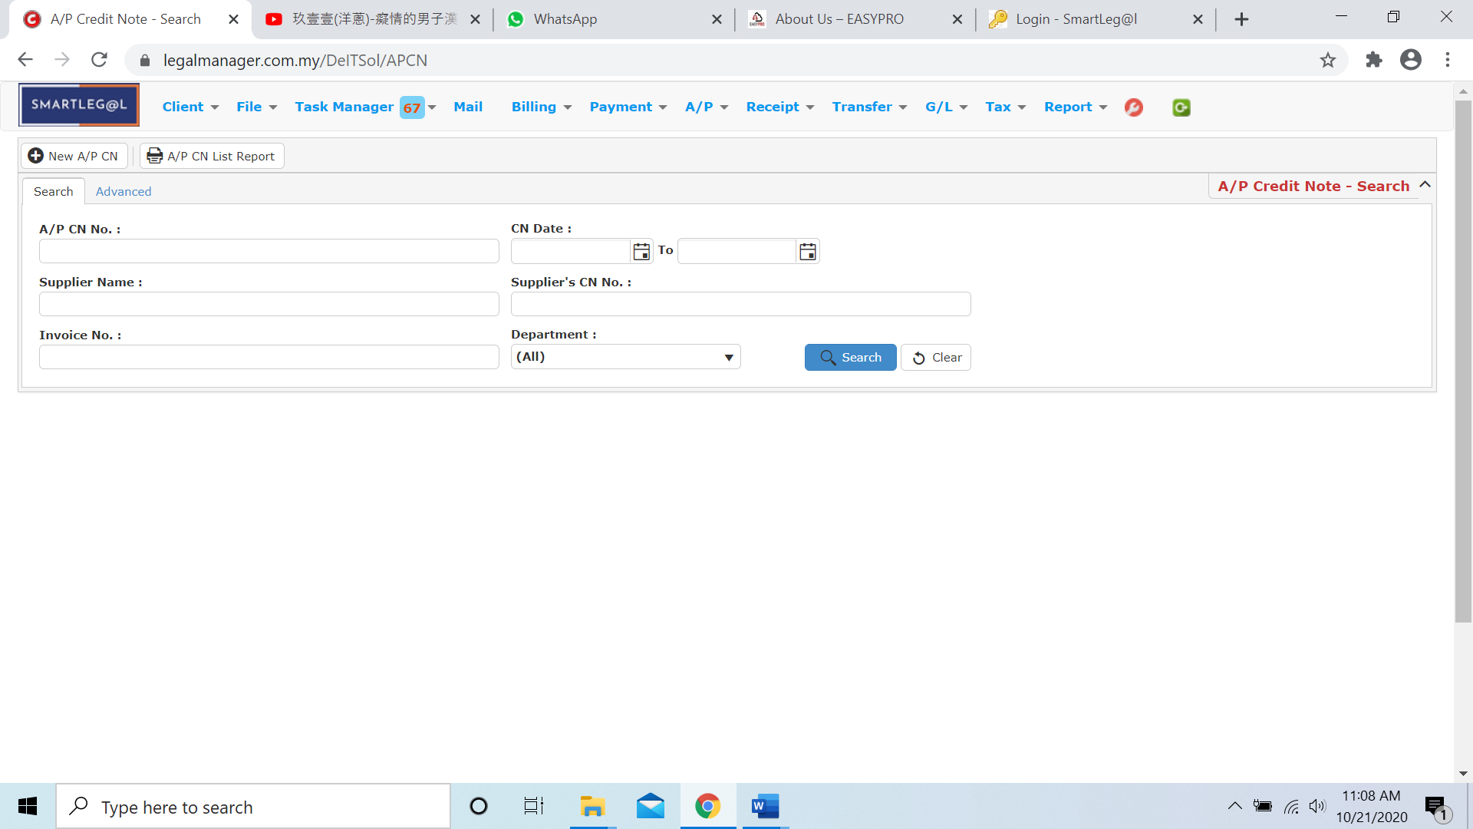

Figure: Manage A/P Credit Note - Search

**Advanced Search**

* This function can be used to find a task by searching other information that is not captured in the ‘General’ section.
* Define search criteria:

**- Field** - Choose the field you want to search.

**- Condition** - Search condition

**- Value** - Type in the detail you want to find.

* Click ‘**Add to list**’, to define more than one criteria.
* Click ‘**Find**’, search results will be displayed at search record list. You can open an item in the search results list by double-clicking.
* To start a new search or to clear the search results, click ‘**Clear**’.
* Click ‘**Export**’ to print the desired search results in txt, excel or html format.

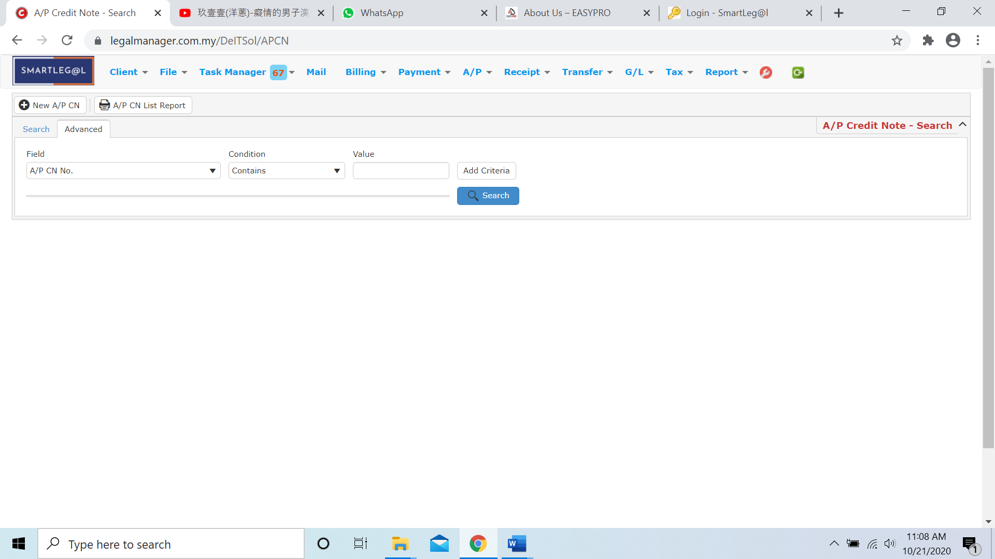

Figure: Manage A/P Credit Note– Advanced Search

* Other than Search A/P Credit Note you can create of New A/P CN by clicking  and it will pop up New A/P Credit Note input form and you may refer to Chapter 7.5 New A/P Credit Note

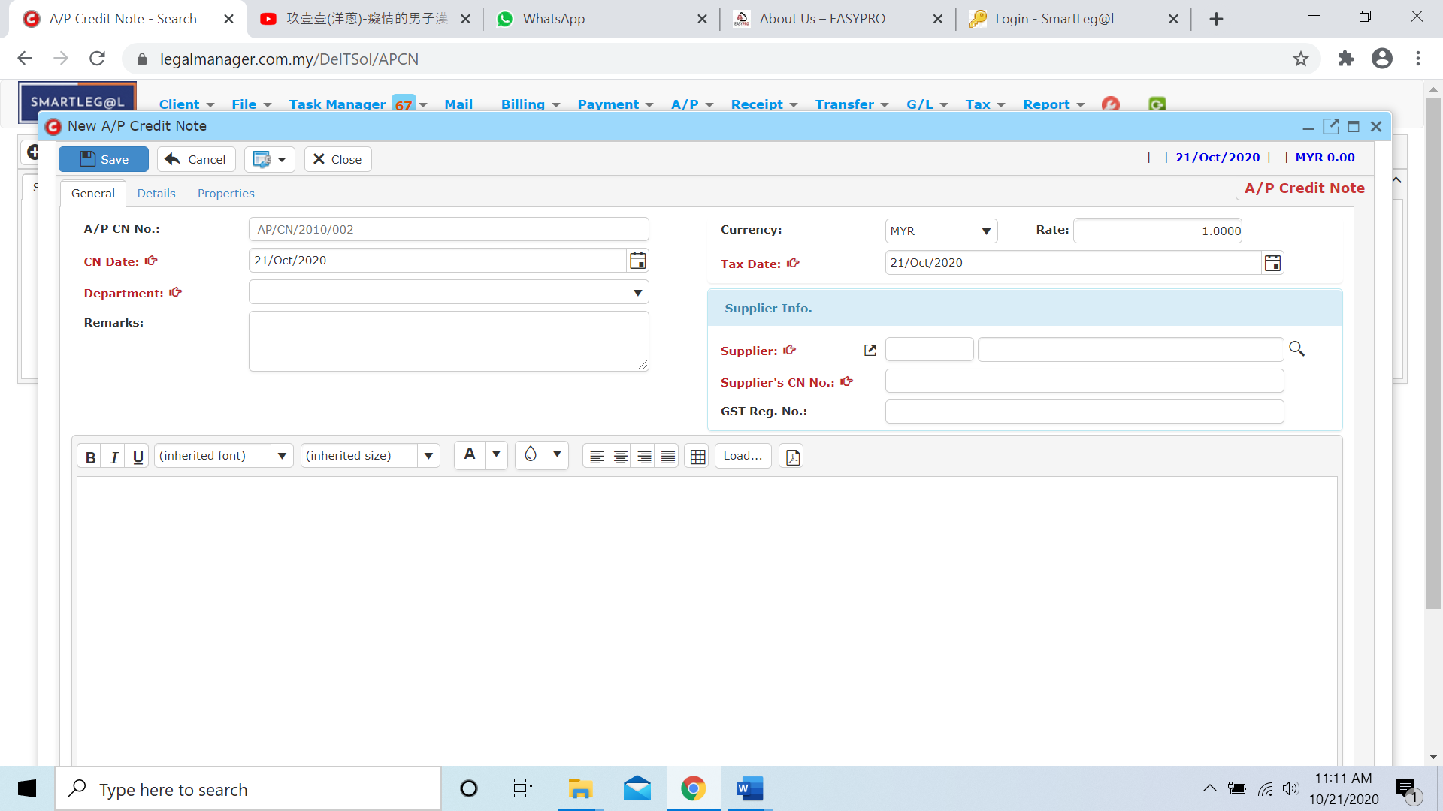

* You can print or preview the A/P Credit Note List Report while you click to 
* It will pop-up a A/P CN List Report as below and you can insert you requirement to filter the report

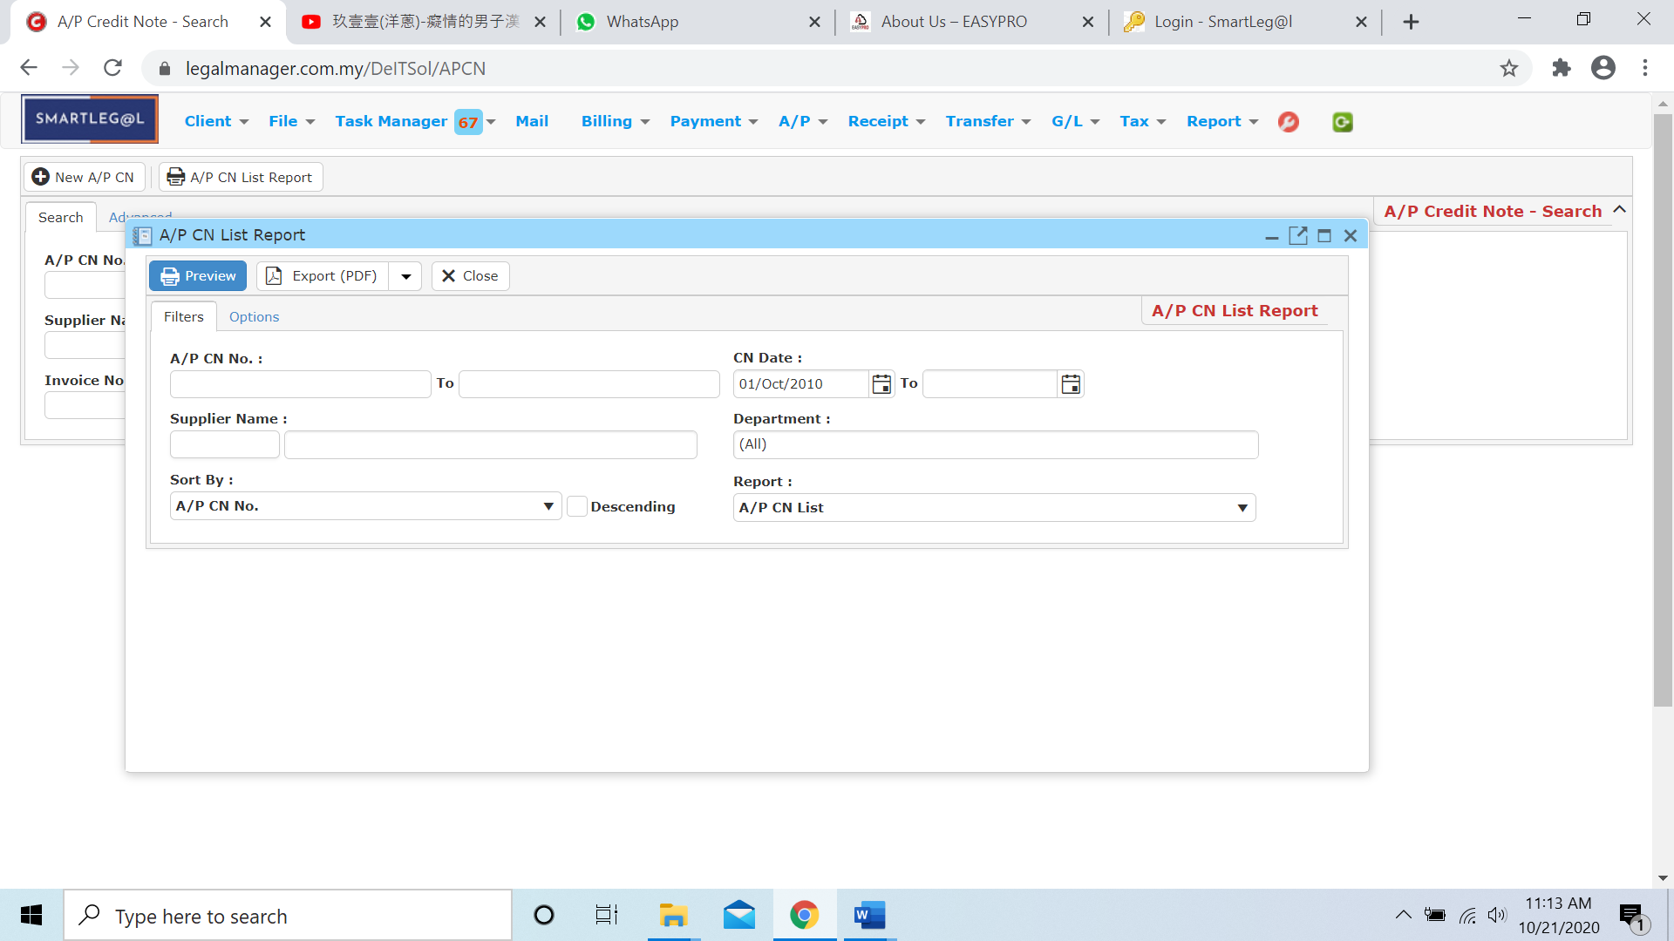

* Besides, you can preview the report as figure below shown

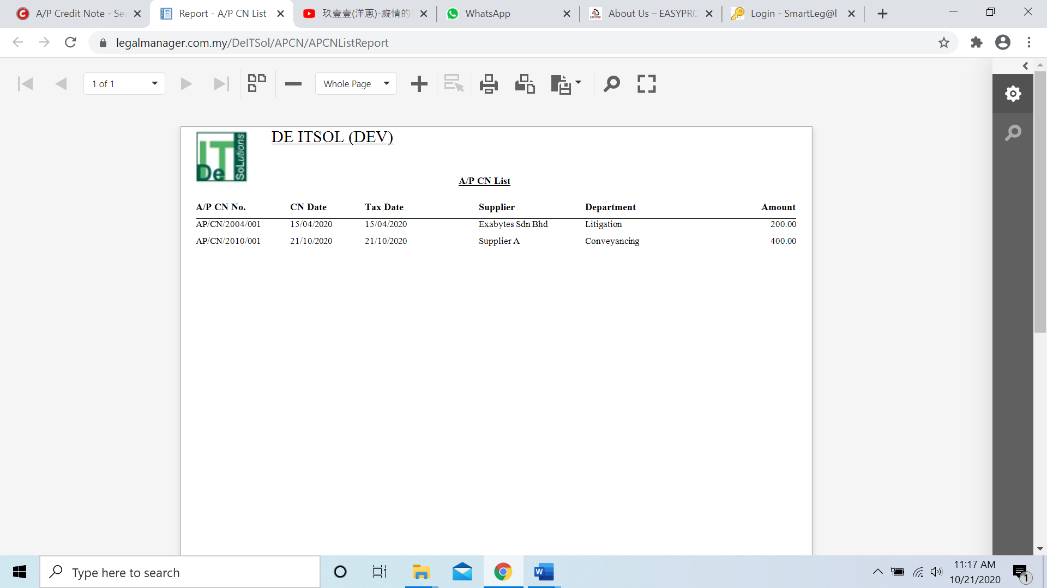

* You can also export the report into PDF or excel by clicking

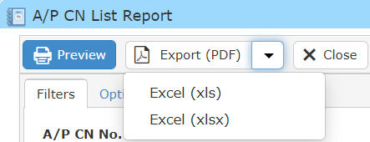

**Searched Result**

* Click ‘**Search**’ once, to show all A/P Credit Note Record
* The Searched result will appeal at below, otherwise it will shown no record availble if the record you searched do not exist.
* Click ‘**Export**’ to print the desired search results in txt, excel or html format.

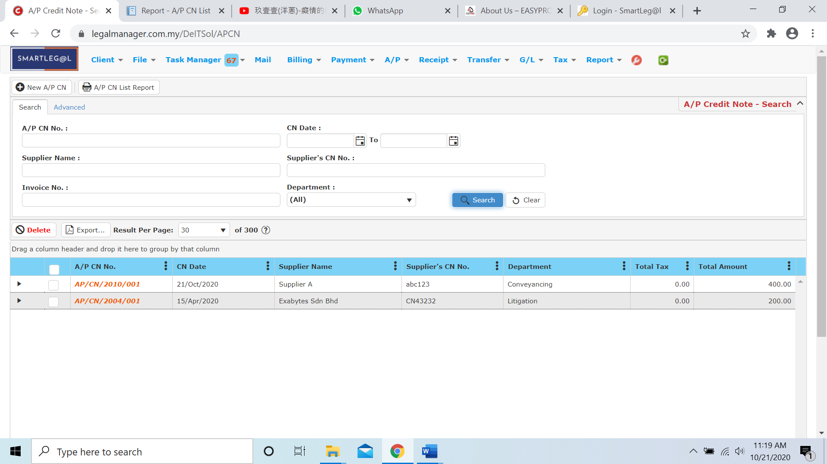

Figure: Manage A/P Credit Note – Search All

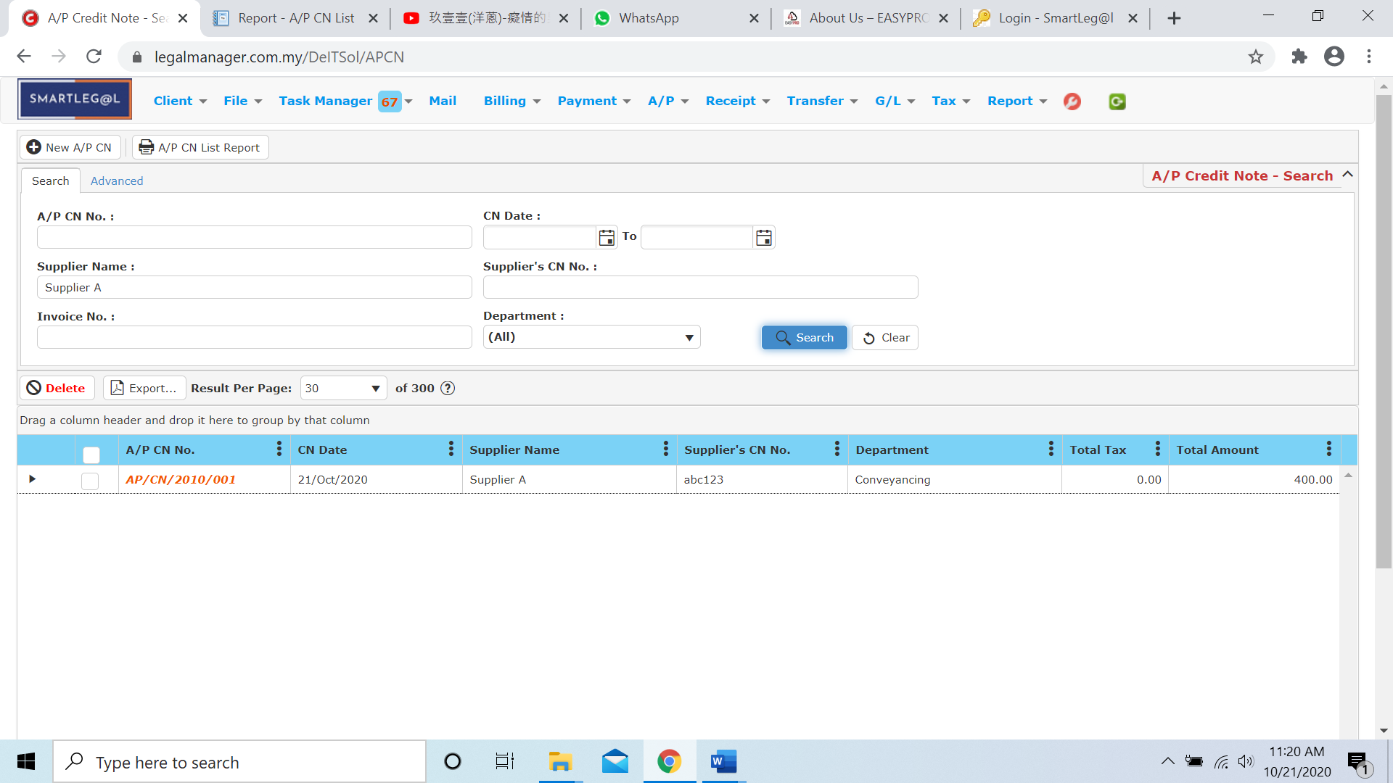

Figure: Manage A/P Credit Note – Searched Result

* After the A/P Credit Note record you searched appeal, you can choose to view, edit and preview those details by double-clicking the record.

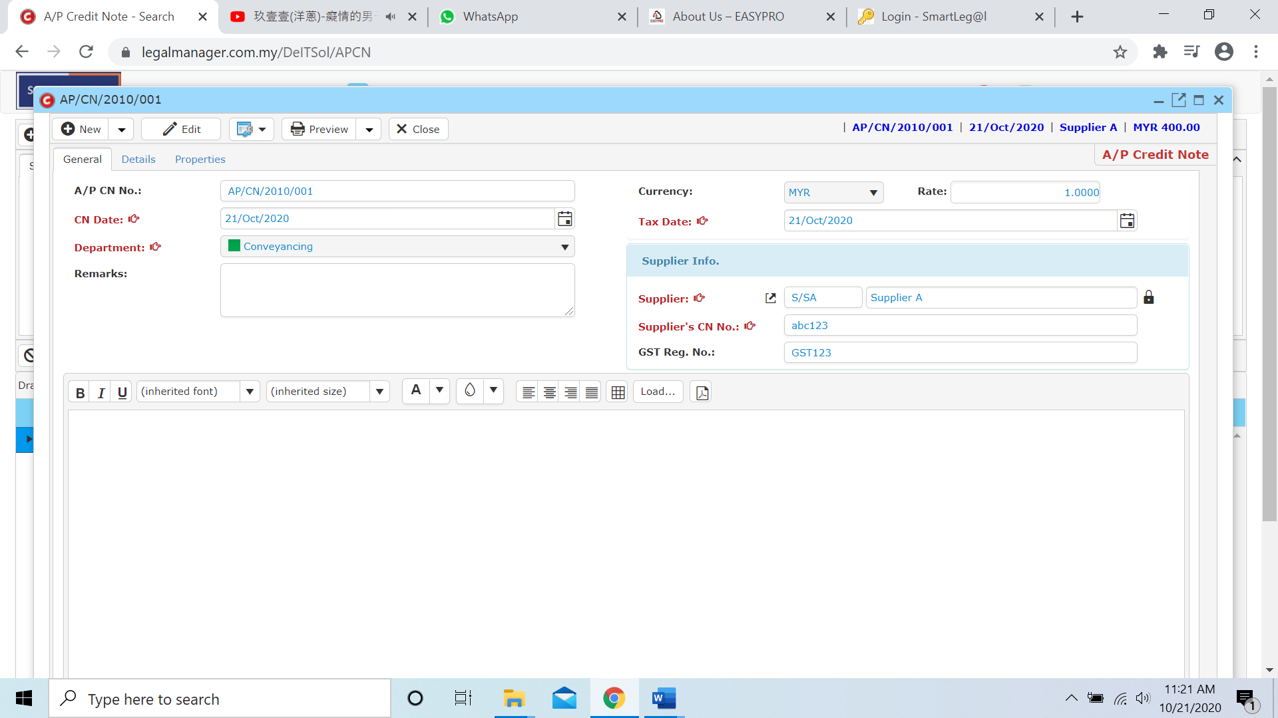

Figure: Manage A/P Credit Note Record – Searched Result, Info

**7.7 New A/P Debit Note**

* To open New A/P Debit Note, on the **SmartLeg@l** navigation, click **A/P** and go to **New A/P Debit Note**.

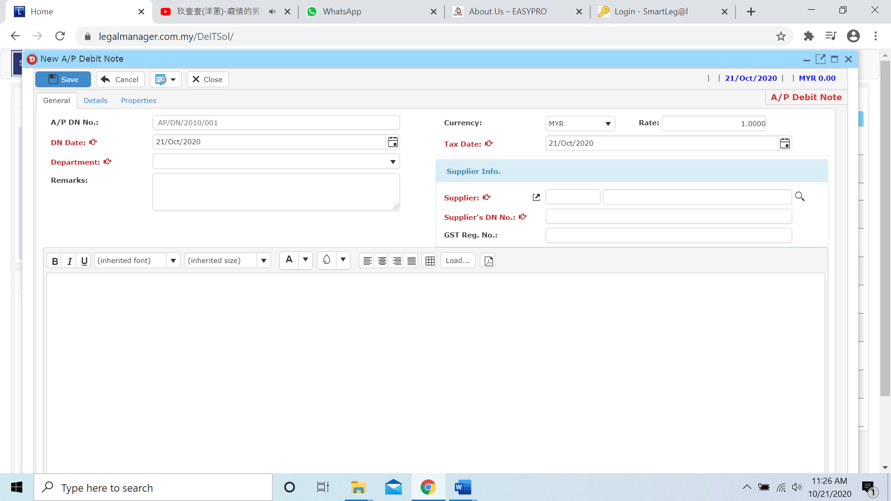

* Select C/N date, Department and Tax Date
* Click  icon to browse your supplier

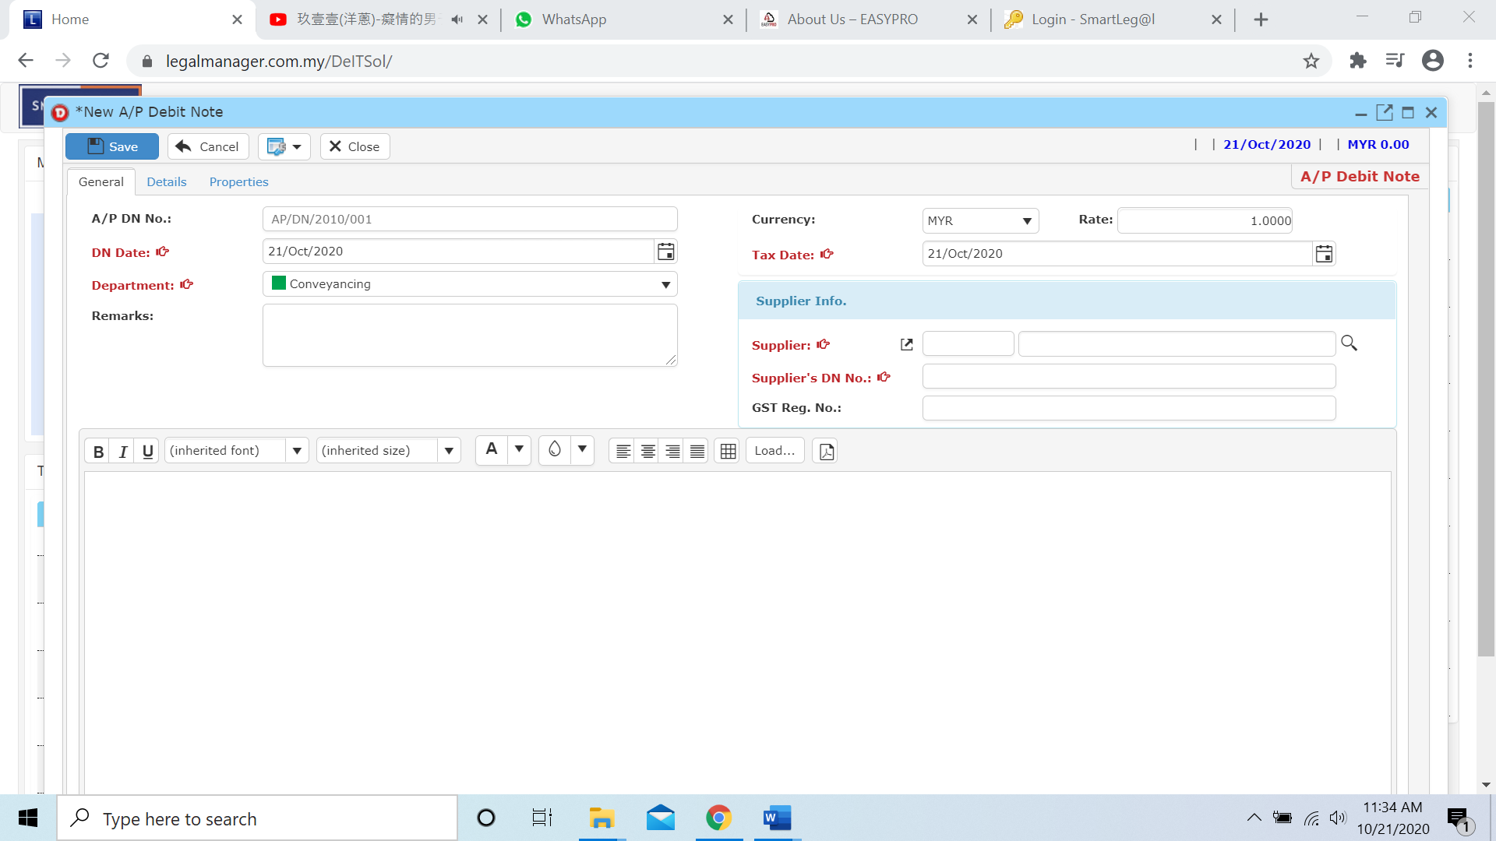

* The Search Supplier will pop up as figure below shown and click ‘Search’ once to show all suppliers

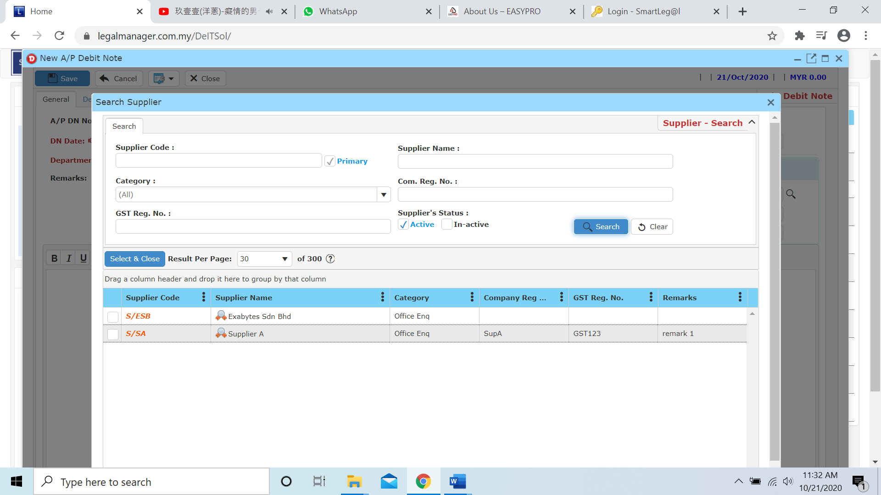

* Click to next tab ‘Details’

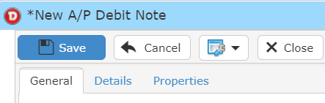

* While you click to details tab, it will auto pop up a search invoice for the supplier you selected
* Click search to your supplier’s invoice

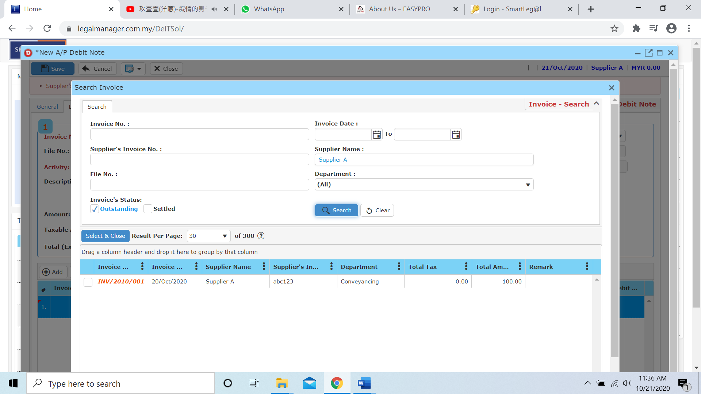

* Once you insert the activity then the debit a/c will auto generate based on the activity you selected or you can select the debit a/c by yourself as well.

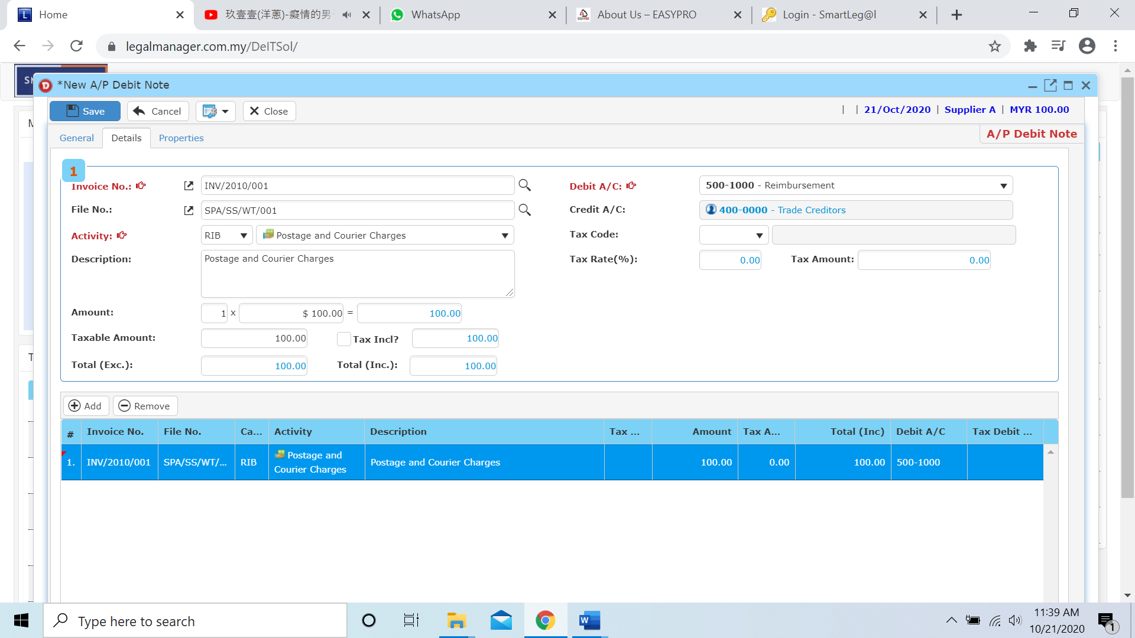

* Other than that, you can Add and Remove the bill in this section



**Add**

* When you click ‘Add’ it will come out a new row and follow the process of above select and key in the activity, debit a/c and amount.

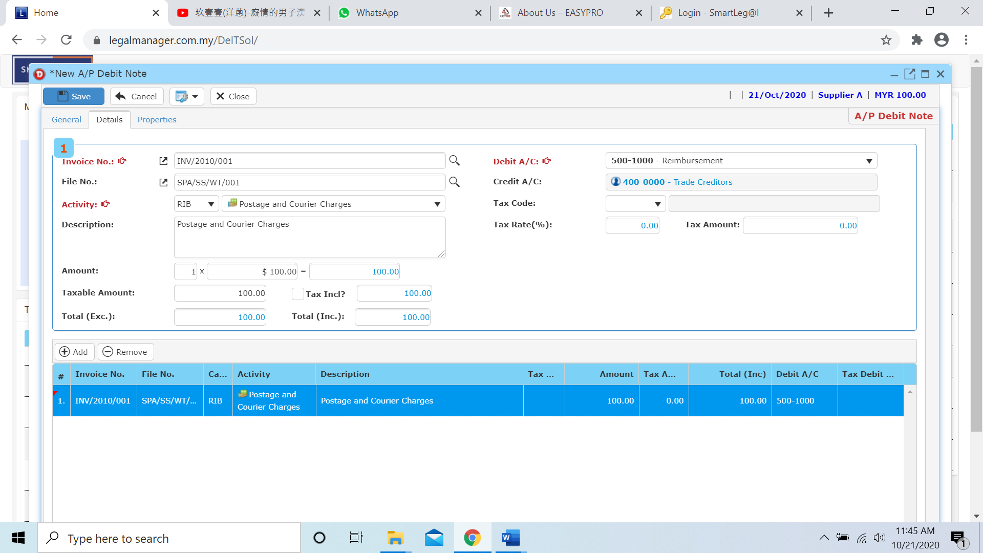

* After you click ‘Add’

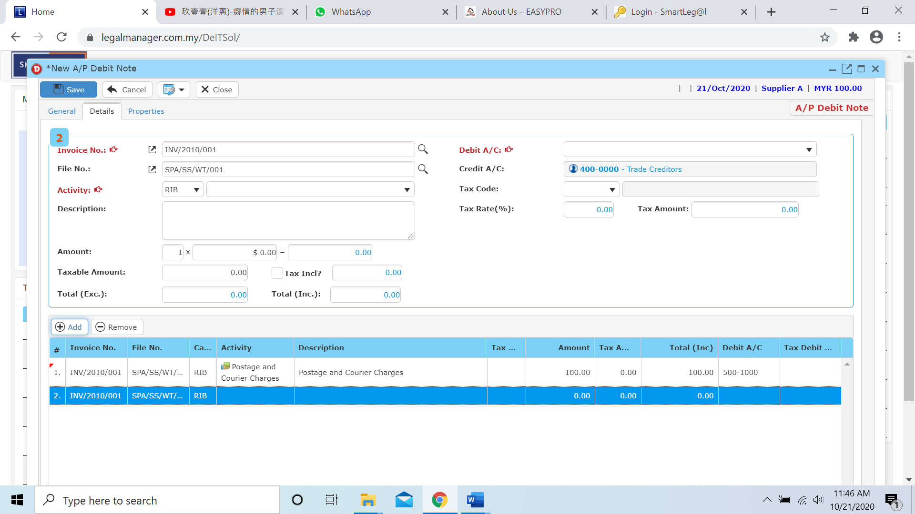

**Remove**

* For the remove, you have to select the bill in the list and click remove to erase the bill

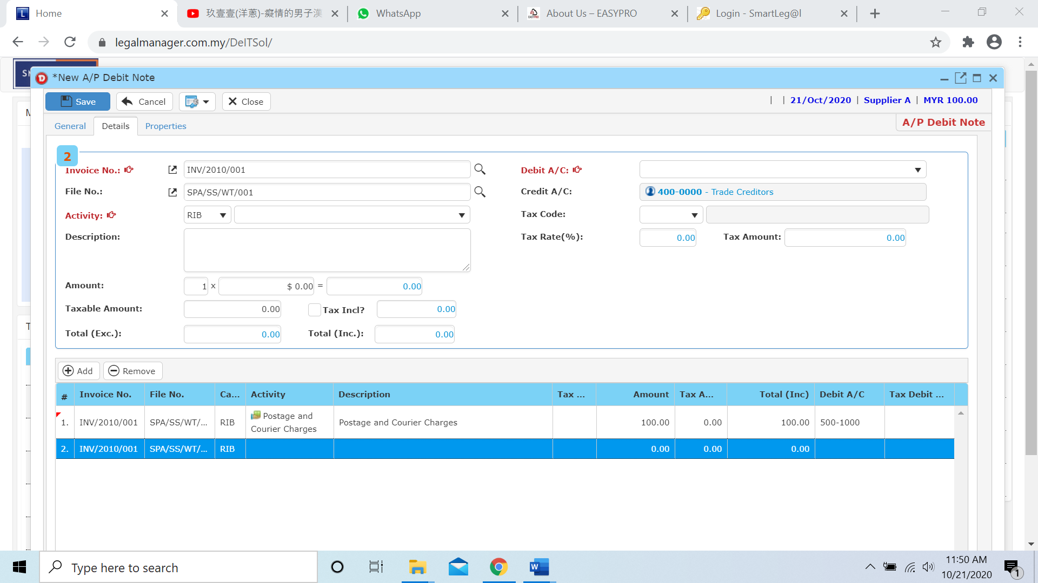

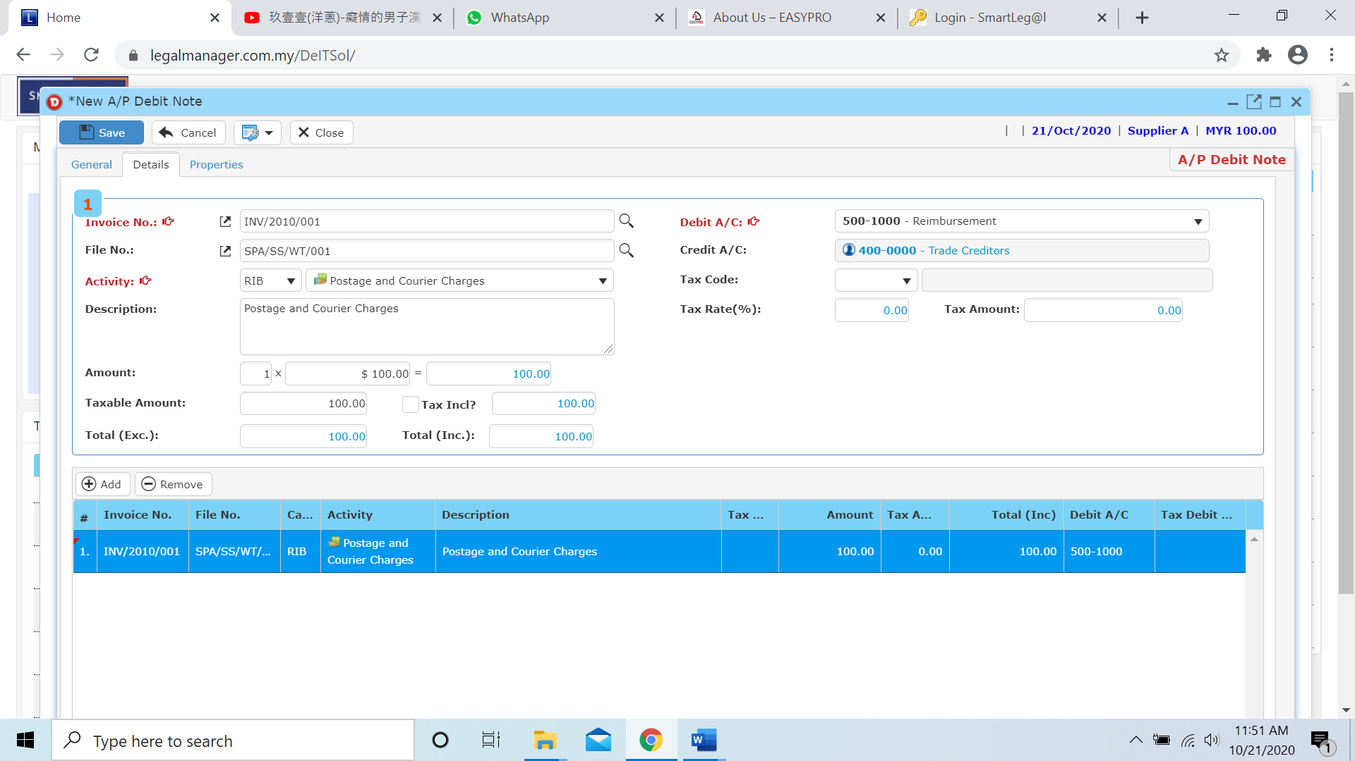

* Click to the next tab ‘Properties’

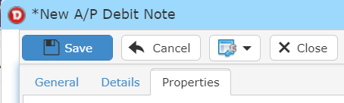

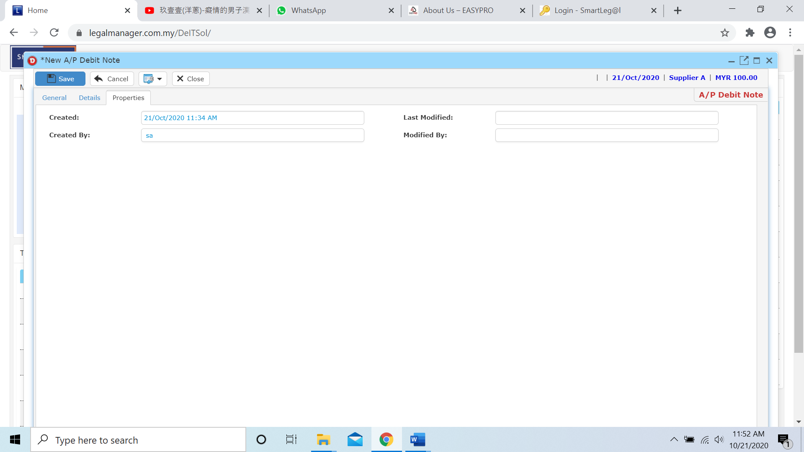

* After you finish insert all the information and details click ‘Save’
* You can view the information of the supplier once who modify the A/P Debit Note then there will show the last modified and modified by who

**7.8 Manage A/P Debit Note**

This option enables you to add, edit, and delete a A/P Debit Note Record. It also allows you to keep track of your A/P Debit Note record details and all related information.

* To open Manage A/P Credit Note, on the **SmartLeg@l** navigation, click **A/P** and go to **Manage A/P Debit Note** then search the A/P Debit Note record you wish to modify.

**Manage A/P Debit Note**

* Search the A/P Debit Note record you wish to manage through type the search criteria or search by advanced.
* To start a new search or to clear the search results, click ‘**Clear**’.

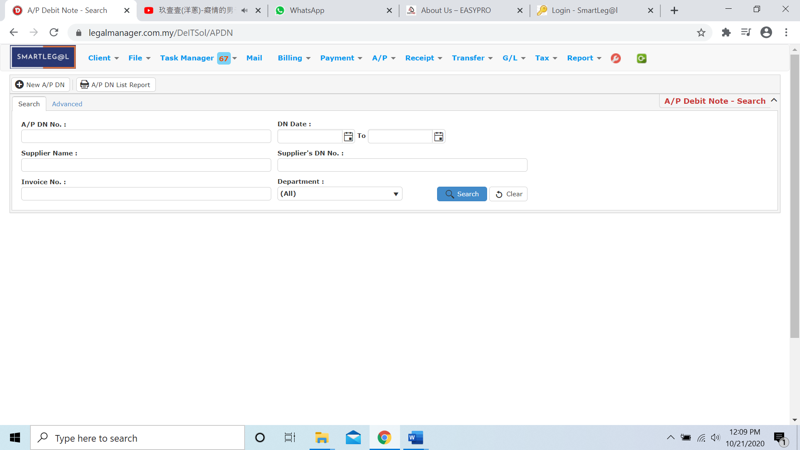

Figure: Manage A/P Debit Note - Search

**Advanced Search**

* This function can be used to find a task by searching other information that is not captured in the ‘General’ section.
* Define search criteria:

**- Field** - Choose the field you want to search.

**- Condition** - Search condition

**- Value** - Type in the detail you want to find.

* Click ‘**Add to list**’, to define more than one criteria.
* Click ‘**Find**’, search results will be displayed at search record list. You can open an item in the search results list by double-clicking.
* To start a new search or to clear the search results, click ‘**Clear**’.
* Click ‘**Export**’ to print the desired search results in txt, excel or html format.

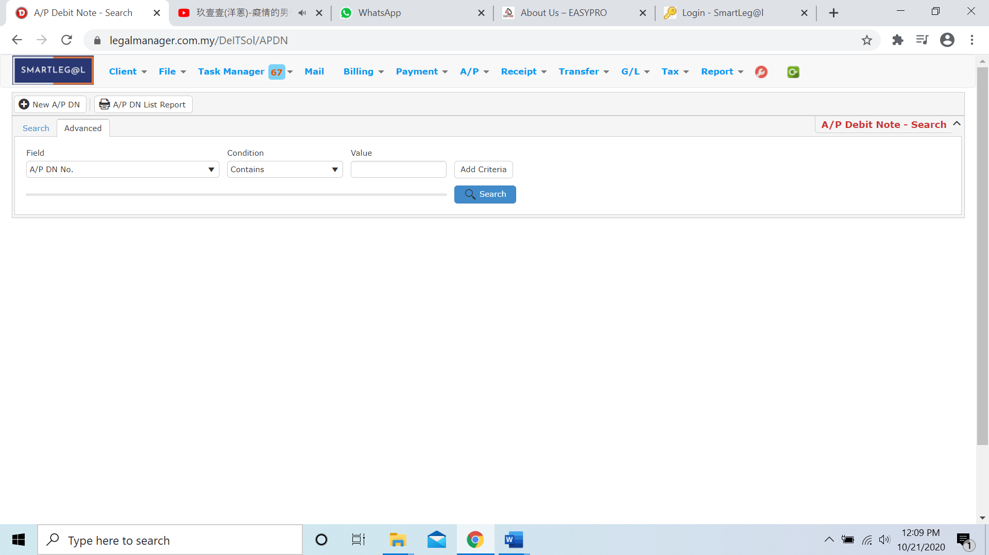

Figure: Manage A/P Debit Note– Advanced Search

* Other than Search A/P Debit Note you can create of New A/P DN by clicking 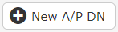 and it will pop up New A/P Debit Note input form and you may refer to Chapter 7.7 New A/P Debit Note

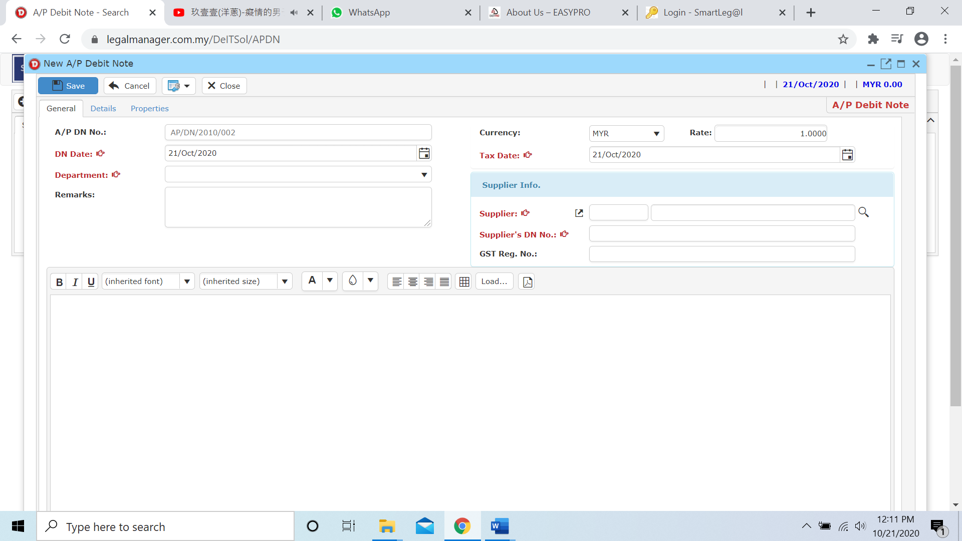

* You can print or preview the A/P Debit Note List Report while you click to 
* It will pop-up a A/P DN List Report as below and you can insert your requirement to filter the report

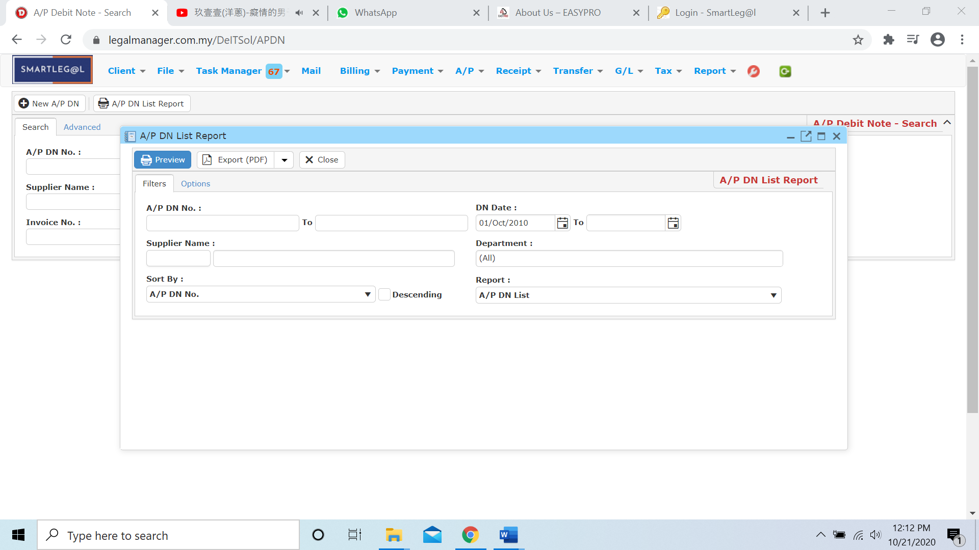

* Besides, you can preview the report as figure below shown

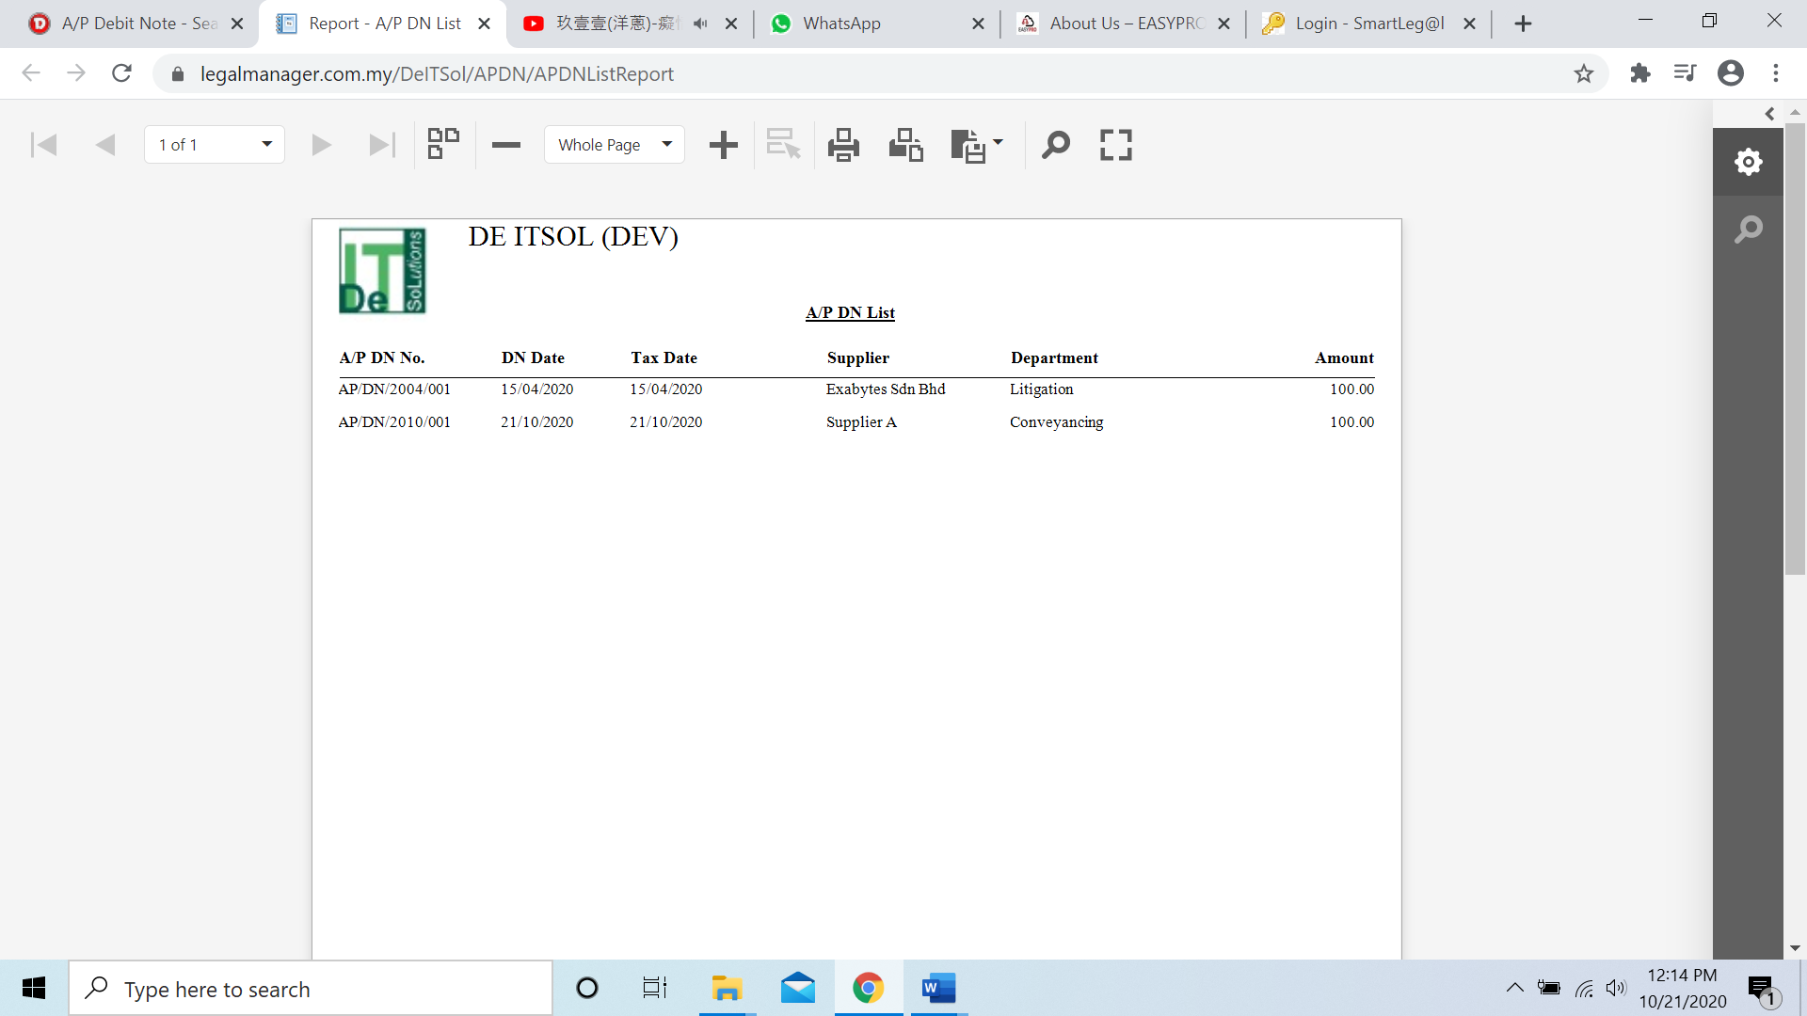

* You can also export the report into PDF or excel by clicking

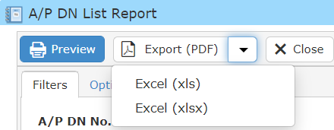

**Searched Result**

* Click ‘**Search**’ once, to show all A/P Debit Note Record
* The Searched result will appeal at below, otherwise it will shown no record availble if the record you searched do not exist.
* Click ‘**Export**’ to print the desired search results in txt, excel or html format.

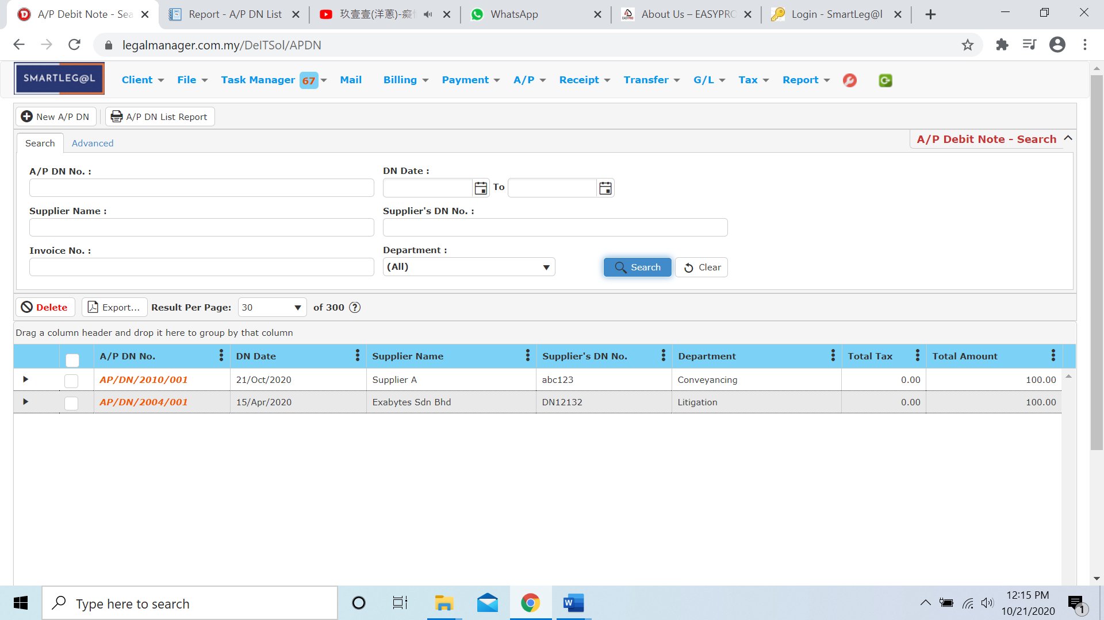

Figure: Manage A/P Debit Note – Search All

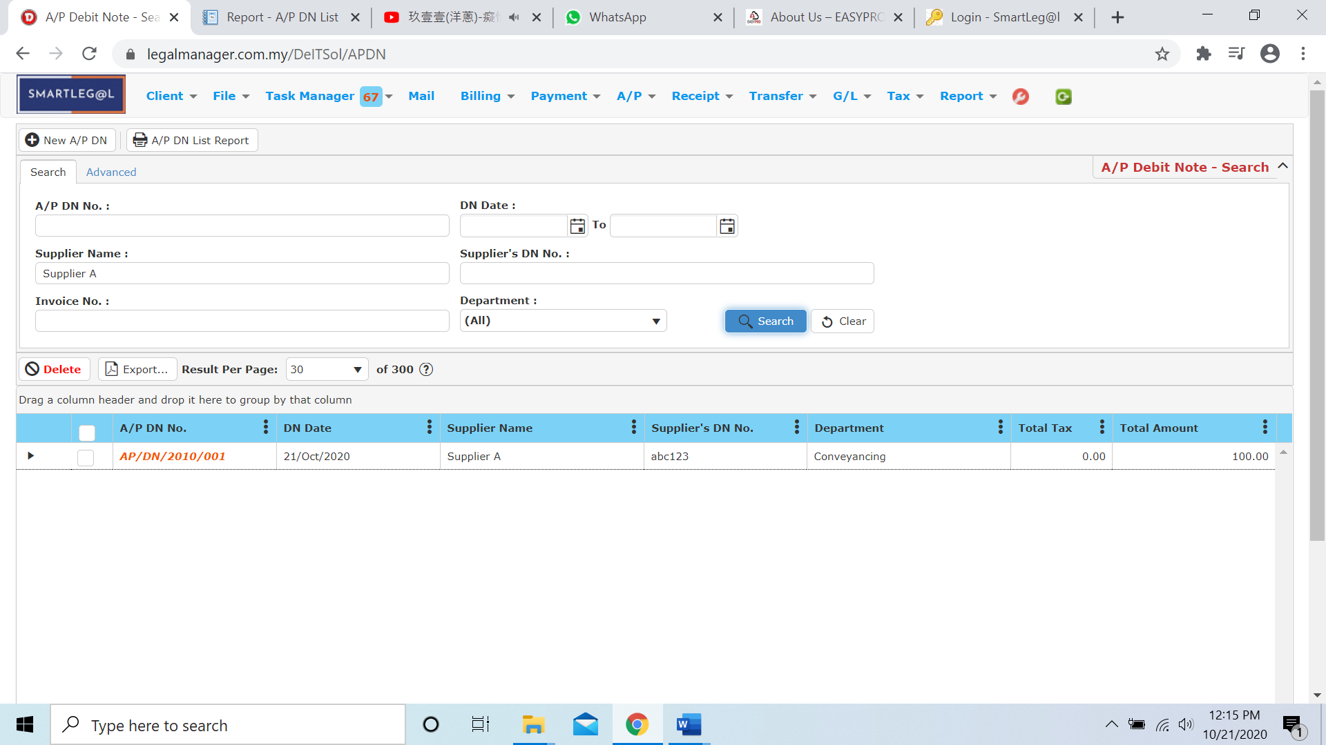

Figure: Manage A/P Debit Note – Searched Result

* After the A/P Debit Note record you searched appeal, you can choose to view, edit and preview those details by double-clicking the record.

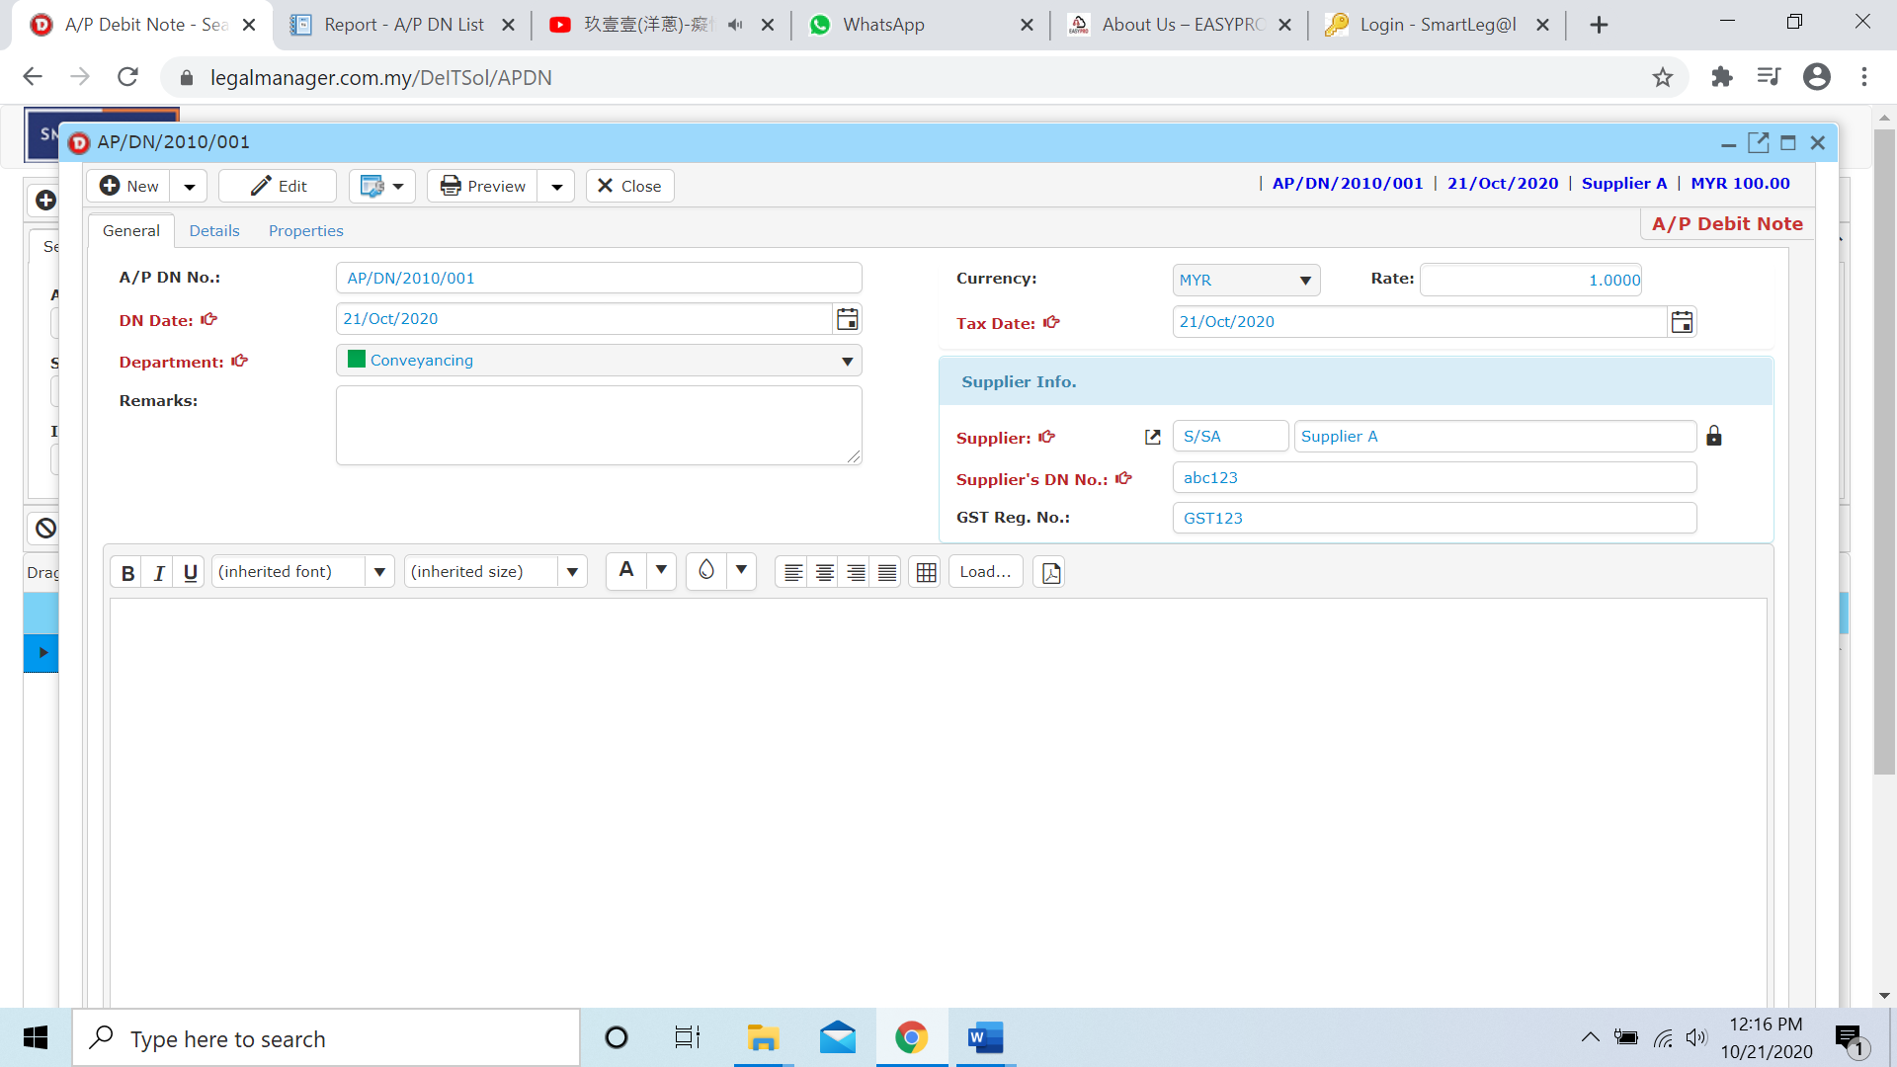

Figure: Manage A/P Debit Note Record – Searched Result, Info